Review
Smart Portable Devices Suitable for Cultural Heritage: A Review
Federica Valentini^{1,2,}*, Andrea Calcaterra², Simonetta Antonaroli¹, and Maurizio Talamo²
¹ Sciences and Chemical Technologies Department, Tor Vergata University, via della Ricerca Scientifica 1, 00133 Roma,Italy
² INUIT Foundation Tor Vergata University, via dell’Archiginnasio snc, 00133 Roma, Italy
* Correspondence: federica.valentini@uniroma2.it; Tel.: +39-067-259-4889
Received: date; Accepted: date; Published: date
Abstract: This article reviews recent portable sensor technologies to apply in the Cultural Heritage (CH) fields. The review (with more than 100 references) has been prepared in the form of a retrospective description of the sensors history and technological evolution, in terms of: new nanomaterials for transducers, miniturized, portable and integrated sensors, the wireless transmission of the analytical signals, ICT_Information Comunication Technology and IoT_Internet of Things to apply in cultural heritage field. In addition, a new trend on screen Printed Electrodes (SPEs) and movable sensors tattoo devices are discussed, refereed to in situ analysis, especially important when scientists are in presence of un-movable and un-tangible Cultural Heritage and Art Work objectives. The new proposed portable contact sensor tools (directly applied on art work objectives and surfaces) result non invasive and non destructive toward different materials and surfaces, of which cultural heritage is composed.
Keywords: Sensors; Cultural Heritage (CH); integrated sensor arrays; actuators; movable devices; ICT; mobile Laboratory; IoT; air quality control; analytical diagnosis; in situ restoration; nanomaterials; graphene; graphene oxide (GO)

1.Introduction
At the state of the art, humidity, temperature sensors (i.e.; thermogeometric integrated sensors [1,2], gas and particulate matter sensor devices [3,4] and smart tools for the monitoring of the biofilms [5] and bacteria [6] represent the most applied tools for the air quality control and monitoring for the indoor [7] and outdoor [8] environment, dedicated to the conservation of Cultural Heritage or the archaeological places. Actually, the sensor market is very appealing (Scheme 1) especially because of several field applications used smart sensor tools to monitor medical health care [9], sport performances with sport app [10], to control the food quality of the organic matrices [11], and for the study of the environmental climate global changes [12]. Considering the global market forecasts, (Scheme 1), smart sensors directly applied on the damaged surface of Cultural Heritage are not reported [13]. In fact, all sensors are dedicated to the monitoring of the environment where CH are located and preserved. This review also focus on several innovative miniaturized sensors, for in situ diagnosis of damaged CH surfaces and objectives. Recently, there are new approaches concerning innovative sensors tattoo prototypes [14,15], that could monitor several pollutants and their corresponding damages, direclty on the Cultural Heritage surfaces, by applying non-invasive and non-destructive strategies. Especially, several new transducers are assembled using nanomaterials, as: carbon based nanstructured materials (i.e. graphene [16]), metallic nanoparticles [17], nanostructured polymers [18] and nanocomposites [19]. The great advantages to use nanomaterials for the assembly of portable sensors, firstly consist on their excellent chemical-physical properties [20], as: higher electrical conductivity [21], higher thermal stability [22], lower Young’s modulus (that is essential to obtain flexible and stretchable electrodes [23,24]); improved optical properties (for the fabrication of transparent electrodic support [25,26]). The nanomaterial performances, combined with the new printing technologies [27] for the fabrication of new miniaturized and integrated sensors chip, seem to be very promising to establish a new era of portable integrated sensors array, extremely useful for Cultural Heritages. In addition, the new generation of sensors tattoo offer the great advantage to be fabricated on compatible materials [28,29] suitable for the in situ analysis of the cellulosic paper and/or membranaceous organic materials, which mainly represent the indoor CHs, preserved in museums, archives and libraries [30]. Recently, several natural textiles are also used for the assembly of new generation of electrochemical sensors tattoo [31,32], mainly compatible toward the ancient manuscripts, to analyze. The mechanical strain on textile-stretchable sensors [33], their analytical performances, as well as the compatibility [34] of the substrate employed in the fabrication procedures, their flexibility and transparency, could provide smart tools highly sensitive to the biochemical-physical modifications of the CH’s surfaces, when exposed to environmental damages [35]. These new sensor prototypes are mainly assembled withnew nanostructured materials, that are chemically [36] or electrochemically [37] synthesised, directly on the sensor tattoo surfaces. The resulting devices exhibit enhanced electrical conductivity [38], high mechanical stability [39], high compatibility [40] especially towards several art-work surfaces, respecting the best criteria of not invasiveness [41] of the original art work objectives.In addition, nanomaterials also result highly biocompatible toward “end-users” (as restorers and conservator scientists), ensuring safe analysis procedures in restorationa and conservation laboratories.
This review firstly focus on the state of the art of the highly performing portable and movable humidity sensors [42],temperature probes [43], pH devices [44] andother several tools specific and selective for the monitoring of gaseous and/or particulate matter pollutants [45,46], that are necessary to determine in order to provide a complete mapping of the conservation status of the Cultural Heritage objectives.
In addition, sensors tattoo new prototypes could represent a challenge in the restoration and conservation fields because these new tools could offer, for the first time, the great advantage to continually follow the damages, directly on the surfaces of the CHs. This is a foundamental aspect to consider because damages on CHs occur not only for external environmental pollution events but also fortheir intrinsic factors,depending on the natural aging of CH’s materials. A combination of portable sensors with the new tattoo devices could offer the great opportunity to better understand the complex and serious phenomenon of the damages of cultural heritages (that is a complex combination of both, external and intrinsic parameters involved in restoration field). Moreover, the tattoo sensors have also demonstrated excellent performances in terms of actuators, capable of releasing cleaning agents, and also restoration and consolidation chemical reagents directly on the damaged historical surfaces. In this case, for the first time, an integrated system of sensors (completely dedicated to the CH diagnosis) and also miniaturized actuators (mainly dedicated to the in situ restoration of CHs) could be assembled. This approach could be extremely useful in presence of un-movable and un-tangible art work objectives and surfaces, avoiding all the problems related to the CH transport, securing of the art work objectives, especially when these CHs are removed from places dedicated to their conservation. The vast majority of these movable sensors could present smart wireless transmission of the signals, allowing a remote management of integrated measurement systems. This last aspect could be very promising for end users (as restorers and conservator scientists), especially when there are continuous monitoring campaigns that can take mostly long term experiments, up to several months of continuous measurements. Recently, the Information and Communication Technology (ICT) systems seem to be the best solution for a remote programming of the operation of portable sensors, as well as for the management of big data, collected for long times environmental monitoring of CHs. ICT also uses a sophisticated Internet of Things (IoT) system, extremely advanced, with which it allows end users to manage the operation of sensors and the collection of the corresponding data, remotely and directly from a handheld interface, similar to that exhibited by a smartphone device. This is the real revolution in the field of cultural heritage, in order to better understand the nature of the damages, with the aim of finding the best solution to keep them longer, to future generations.
According to these considerations, this review is organized in two main sections:
-the first one, concerning a description of the portable devices and the innovative sensor tattoo, with their applicability on CH fields;
-the second one, concerning a description of the miniaturized, integrated sensors interfaced with ICT and IoT, which can certainly start the new concept of a mobile laboratory, autonomous in the planning of long time measurements (to perform in both strategies, as diagnosis and restoration applications) and final management of the corresponding big data.
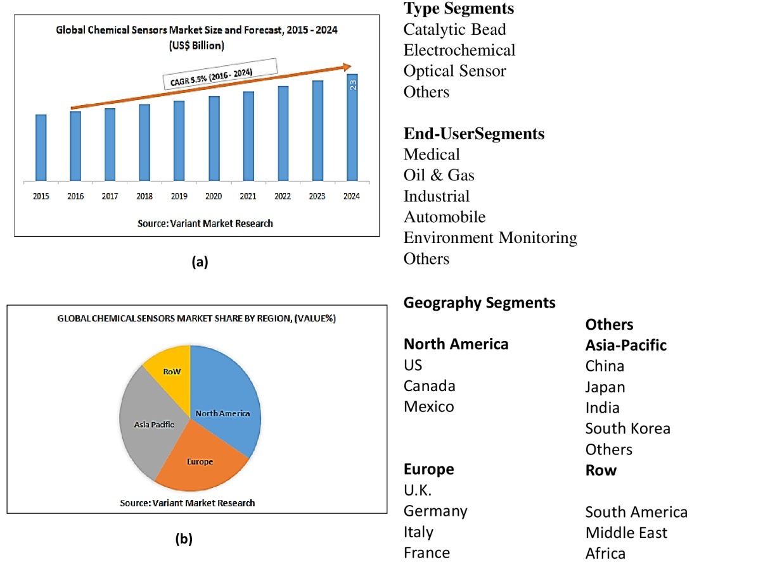
Scheme 1.(a): The global market of the chemical sensors and the corresponding CAGR%; (b): the geographical distribution of the sensor market [13].

2. I section: portable devices for humidity, temperature, pH
Recently, in the sensors field application the miniaturization trend seems to be very promising because in situ diagnosis and in loco remediation of damaged CHs, can be easily performed. In the first section of the review, the main highly performance miniaturized sensors are described, and listed in the following paragraphs.
Miniaturized optical sensors humidity. Fiber devices seem to be very powerful for the fabrication of portable sensor humidity because there is the possibility of multiplexing of different sensors (temperature, displacement, pressure, pH value, humidity, highmagnetic field and acceleration) into the same optical fiber tool, minimizing the multiple cabling used in conventional commercial electronic devices [47a]. Relative Humidity %, Temperature and pH levels represent the main useful parameters to quantifiy, when in presence of damaged CH samples. According to what was stated, a practical testbed applied in Fortaleza São Tiago museum, located in Madeira Island, Portugal has been also reported here, as an example of CH field application. In this case, three Crossbow [47b] mica2 motes, equipped with an MTS400CA data acquisition board and a mote equipped with a mib520 board (representing the base station), have been installed in themuseum The MTS400CA data acquisition board measures: ambient light, relative humidity, temperature, 2-axis accelerometer, and barometric pressure parameters. This board has a conventional fiber based humidity sensor and temperature probe, the Sensirion SHT11, which measures temperature values ranging from -10 to +60°C and humidity values, ranging from 0 to 90% RH. To improve the Sensirion SHT11 accuracy, the Sensirion SHT15 was also subsequently installed in the same museum (Madeira Island, Portugal). The acquired data show typical variations of temperature and humidity values, throughout the day and night, in a single room of the museum. In particular, authors verify that temperature varies about 2°C whereas, the relative humidity varies about 6% RH. According to the museums’ managers, these variations result as typical values, especially during winter time. Instead, these parameters exhibited much higher values in the summer, accordingly to the day and night periods, or when the lights are turned on or off. These parameters are not constant, as it should be in ideal conditions of CH conservation in museums. According to this, sensors Sensirion SHT15 was suitable to monitor the conservation status of this museum, conferring on restorers and conservator scientists the great opportunity to select the correct restoration and conservation strategy toward the works of art, specifically preserved in that museum, reported on reference [47b].
Another recent example is represented by a sensitive transducer layer, made of an organic-silica hybrid material. This latter is the di-ureasil humidity sensitive layer, that consists of polyether chains with 600 g·mol⁻¹ (labeled as d-U(600)), as the average molecular weight of covalently linked to a siliceous inorganic skeleton by urea bridges [48]. Its volume reversibly depends on distinct levels of RH, which in this way can be quantified. The average diameter of the deposited d-U(600) sensitive layers, on the optical transducers, ranging from 375±5 μm and 591±5 μm. The d-U(600) layers were deposited on the transducer sensors by using a dip-coating strategy. The dip-coating process was performed at room temperature by immersing the transducer verticallyin the d-U(600) solution, at a velocity of 1.4 mm·s⁻¹.After deposition, the fibers were transferred to the oven and kept at 50 °C for 40 h. In all the cases, the d-U(600) coating revealed strong adhesion to the optical fiber and mechanical stability (inserted in a protective stainlesssteel tube, see Figure 1A). Recently, improved sensor fiber tools are obtained by using graphene, an interesting and highly performance nanostructured materials, exhibiting excellent chemical-physical, mechanical/engineering and bio-chemical properties [49]. An innovative humidity sensor, based on power leakage at resonance wavelength, in a reduced graphene oxide coated fiber, is developed [50]. The hollow core fiber is coated by using reduced graphene oxide nano-dispersion, and a Fabry–Perot resonator is obtained in the cladding region (Figure 1B). The leaky mode of the guided light is reached at resonant wavelength of the Fabry–Perot resonator, which results in lossy dip in the transmission spectrum of the hollow core fiber. Consideringthe tunable refractive index of the reduced graphene oxide, the humidity isquantified by using the transmission intensity of the lossy dip. Data show a sensitivity of up to 0.22 dB/% RH. The humidity reduced graphene based sensor exhibits good repeatability, fast response time, and low temperature cross-sensitivity, resulting very eligible for in situ monitoring of the conservation status of CHs.

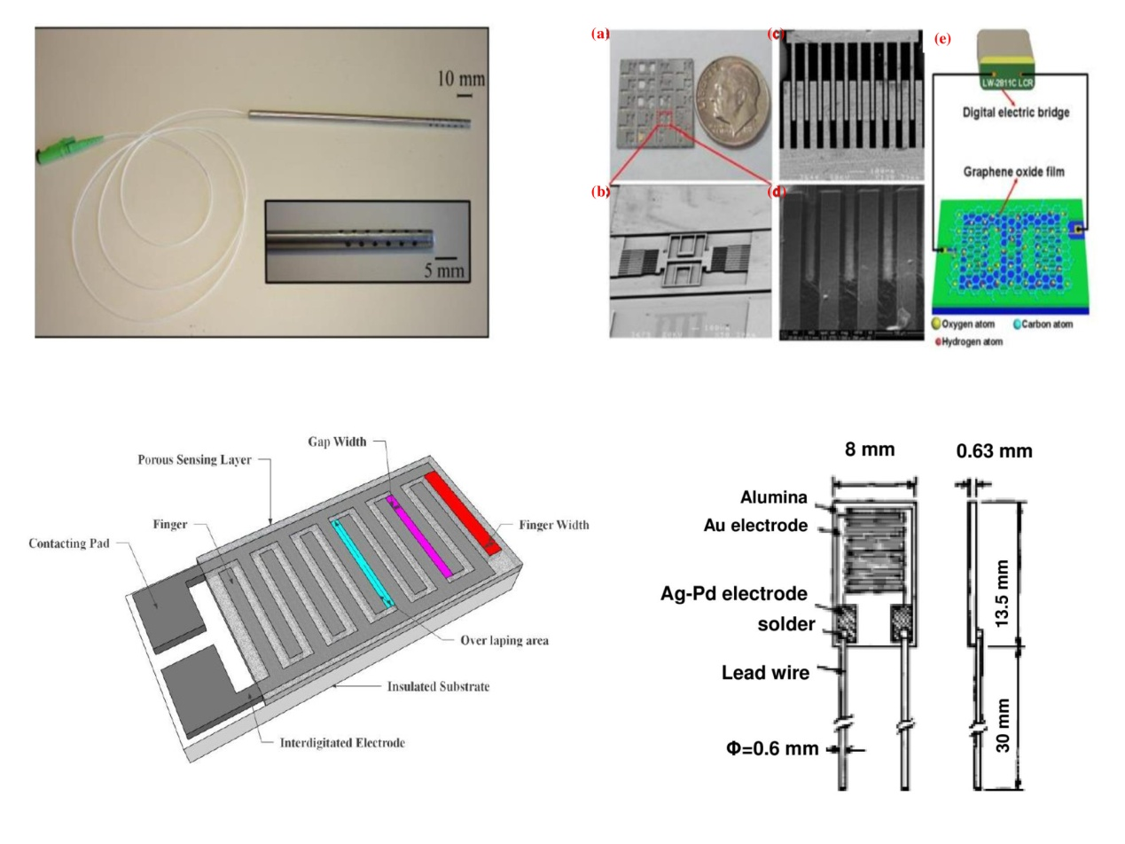
Figure 1. (A): Prototype of the improved RH optical sensor equipped with a protective stainlesssteel tube [48]; (B): Characterization of the sensor and humidity testing system[54]. (C): Sketch of a planar thick/thin film-based humidity sensor based on theinterdigitated structure with the porous sensing element [57]; and finally (D): schematic view of the Hument HPR type humidity sensor device [57].

Miniaturized capacitive sensors humidity. MEMS (Micro-electro-mechanical systems) technology and nanomachining techniques provide a wide impact on the miniaturization of sensors and portable integrated devices. Lee et al. [51a] developed a novel fabrication process for Pt resistor temperature detectors (RTD) and micro-cantilevers covered with a water sensitive polymeric layer (i.e. they are organic MEMS). Then, these devices are put in an integrated humidity sensor as a micro temperature sensor and a micro capacitive humidity transducer, respectively. Wireless sensor platform installed at The Cloisters, the medieval branch of the New York Metropolitan Museum of Art, are presented here as case of study for CH application field. In this specific case , reported by [51b], the temperature transducer is based on a semiconductor diode element (TMP112 with 12-bit resolution, Texas Instrument, Dallas, TX, USA) with an accuracy of 0.5 °C. The air temperature probe is used to study the thermal stratification along the height of a gallery and also slight temperature gradients between different galleries. The relative humidity (RH) sensor device is based on a capacitive element (SHT21, 14-bit resolution, Sensirion, Stafa, Switzerland), with an accuracy of ±2%. The RH transducer is useful for evaluating air moisture levels.
This wireless combined probes offer the great opportunity to continuously monitor the museum indoor temperature profile, for the whole year. The average HVAC set-point (Heating,
Ventilation and Air Conditioning) is fixed at around 20.1 °C and there are small fluctuations (i.e.; deviation of 0.5°C degree) in temperature, around the long term average. The measured value of 20.1°C into the the Cloisters, the medieval branch of the New York Metropolitan Museum of Art, very well agrees with the temperature reference standard values described by UNI 10829: Works of art of historical importance. Ambient condition for the conservation. Measurement and analysis, Milano: UNI Ente Nazionale Italiano di Unificazione, 1999 (in italian language); and also by UNI 10969. Cultural heritage. General principles for the choice and the control of the microclimate to preserve cultural heritage in indoor environments. Milano: UNI Ente Nazionale Italiano di Unificazione; 2002 [in Italian language]. Temperature is also strictly related to the relative humidity profile, and obviously, changes in indoor relative humidity can be detected when the difference between the outdoor and indoor relative humidity is relatively large. The most significant thermohygrometric impact occurs in the summer/autumn time, at The Cloisters museums, investigated by …[51b], as a case of study. An influx of outside air, due to the opening and closing of the museum doors, involves an entry of moisture, which may lead to undesired condensation on cooler art work objects inside the museums.
Especially, in the case of the capacitance-type integrated humidity sensor, miniaturized electrodes are produced by coating a micro-fabricated cantilever with a new micro-structured material [52] and recently also with an innovative nanostructured sensitive layers [53]. Nanomaterials are eligible for their excellent properties, if compared with that exhibited by the traditional polymers (i.e. the Polyethylene naphthalate (PEN)), applied a sensitive layer of the humidity transducers. An example of the nanostructured sensitive water layer is graphene oxide nano-dispersion (having a concentration of 1.0 mg/ml) that was dropped on the sensing area of the chip. The absorption of water moleculesis responsible for the expansion of the upper layer of the cantilever, inducing a surface tensile stress. This provokes an upward bending of the suspended structure away from the glass substrate, which modifies the capacitance parameter between the two structures. Compared with traditional capacitive humidity sensors, the G-O based humidity devices hows a sensitivity of up to 37800% which is more than 10 times higher than that exhibited by the conventional sensors at 15%–95% relative humidity [54]. Moreover, the proposed humidity sensor shows a fast response time (less than 1/4 of that of the conventional one) and recovery time (less than 1/2 of that of the conventional one). Therefore, G-O appears to be an ideal material for constructing humidity sensors able to improve several critical aspects, as: low sensitivity, delayed response and recovery times, less stability, and narrow humidity detection ranges. Rathi et al.; [55] fabricate a highly sensitive chemiresistive sensor for low-level humidity detection in ambient atmosphere by introducing graphene oxide (GO) and doped GO (Li-doped GO and B-doped GO) as a thin water vapour sensitive film. The sensitivity, repeatability, and stability studies reveal that thin film-based fabricated humidity sensors are highly efficient in the detection of different percentages of humidity, ranging from 11 to 97% at room temperature. The incorporation of doping into GO induces a dramatic change in the sensing behavior of the base film (undoped GO).

Miniaturized magnetoelastic humidity sensors. In this paragraph, two cases of study are described, with the corresponding sensor prototypes, both based on nanomaterials, as sesntive layer for aqueous vapor content. The first one, is the experimental set up reported by Varghese and Grimes [56] where a humidity-sensitive thin films made of ceramic, nanodimensionally porous TiO₂, was used for the assembly of remote query humidity sensors.Probably, the honeycomb structure, with a pore size of approximately 80 nm, makes the ceramic layers suitableto quantitatively trap moisture. The sensors were tested in a 50 cm diameter of the cylindrical humidity chamber (1m length), about which a ten-turn pick coil was wound. Results demonstrate the resonant frequency of this magnetoelastic humidity sensor in response to high and low relative humidity levels, of 60% and 2%, respectively. The corresponding mass change of the sensor between the two extremes is approximately 1.7 mg, or 3.7%. Experimental data show the reversibility of the magnetoelastic humidity sensor, with the resonant frequency, measured at increasing and decreasing humidity levels. The sensor was held at a constant humidity level for 10 min prior to each measurement. A deviation from response linearity, presumably is related to the rate-limited diffusion times of the ceramic materials. In order to improve the analytical performances of the sensors, especially in terms of the linearity of the responses, the second case of study is presented here, according to the literature [57]. Alumina films were synthesised by anodizing aluminum thick films protected on the back side by an adhesive layer (Figure 1c). The anodization technique provides self-organized alumina pore arrays from the aluminium support. Sensors having a 13.6 nm pore size, standard deviation ≈ 2.6 nm (Figure 1d), showhighly performances toward the humidity quantification/detection. The impedance variation signal is higher (if compared with the conventional transducers, described in literature [58]) more than three orders of magnitude, for RH values, rangingfrom ~20% to ~90%, with a response time of ~95 sec. The signal response of this device seems to be related to two competing impedance determining processes, occurring in the sensors. The first one is namely charge transfer and the second ones is the mass transport through the physisorbed water layer, as dependent upon the humidity level of concentration and the input signal frequency. Charge transfer enhances the sensitivity, provoking a large variation in impedance, in presence of different levels of humidity. Mass transport leads to accumulation of ions at the electrodesurfaces that induces a decreasing of the sensitivity and an increasing the impedance at the electrode surfaces. Therefore, a proper optimization of the operating frequency, high enough to avoid ion accumulation, is fundamental to improve the sensor analytical performances. As the remote query magnetoelastic micro-sensor arrays small enough to be easily allowed, readily monitored over several tens of centimetres, and has a small enough unit material cost to enable use on a disposable basis, thetechnology appears ideally suited for simultaneous monitoring of pH, temperature, and pressure (i.e. the multi-parameters device). In the case of pH measurement, the pH responsive poly(acrylic acid-co-isooctylacrylate) based transducer, was synthesized at 70°C by free radical copolymerization of acrylic acid and isooctylacrylate, according to the literature [59] on the 2826MB ((Fe₄₀Ni₃₈Mo₄B₁₈) sensitive surface of the assembled pH transducer. Results demonstrate that the calibration curve, for a polymer thickness layer of 0.7 μm measured at 23.1°C, shows the response profile of the same sensor with pH decreasing from 7.5 to 1.3. The pH sensor shows greatest sensitivity between pH 4 and 7.5, with a resonant frequency shift of approximately 0.6%/pH units. The sensor platform is wireless, and it detected the output signal through the use of a remotely located pickup coil.
An example of a remote query ammonia wireless sensor, combined with a free-standing magnetoelastic thick-film coated with poly-acrylic acid-co-isooctylacrylate, is reported in literature [60], where mass changes in presence of different concentrations of the atmospheric ammonia gaseous pollutants. The mass of the polymer layer influences the resonant frequency of the ferromagnetic magnetoelastic support, and for this purpose monitoring the frequency response of the sensor, atmospheric NH₃ concentration levels can be quantify remotely, without the need for physical connections to the sensor or specific alignment requirements. The sensor linearly tracks ammonia concentration below 0.8 vol.%, and tracks higher concentrations logarithmically; within the linear calibration range, a 0.02 vol.% change in NH₃ concentration can be revealed [61]. The miniaturized magnetoelastic sensors, reported here, could be suitable for the assembly of an integrated portable multiparameters array, useful for the monitoring of the conservation status of CHs.
Miniaturized and portable diffusive samplers for gaseous molecular pollutants. The measurement of gaseous and particulate pollutants in museum, libraries, galleries and archives is important to assure acceptable conditions for the protection of CHs displayed or stored in indoor environments. Diffusive miniaturized samplers (Figure 2a) were developed for the assessment of various gaseous molecular pollutants [62] as a simple and less expensive alternative to traditional macroscopic sampling methods, previously employed for the environmental monitoring of the air quality in indoor environments [62]. If compared with the active samplers, in which air is brought collected by using a pump, diffusive samplers bring the pollutants into contact with the collector, only by the spontaneous diffusion processes (as unique mechanism for the capture/up-take of gaseous pollutants, from the troposphere). The first assembly of two badge-type passive samplers, having different lengths, has been studied for the determination of NO₂ and SO₂ gaseous pollutants [63]. The samplers contain a filter membrane barrier to damp out eddy motions and promote pollutants diffusion from the environment to the selective and specific pollutant trapping medium (i.e. the sensitive up-take layer). For example, the determination of NO₂ is performed by using a carbon filter coated with sodium carbonate and glycerine, at these concentration values:1% sodiumcarbonate + 1% (m/v) glycerine in water/methanol(50/50) solution for 2 min. The excess solution drained, and the filters dried in a oven at approximately 70°C. The filter of carbon paper of 28 mm diameter were cleaned twice with aboiling Dionex eluent solution (3.0 mM Na₂CO₃/0.3 mM NaHCO₃, in water) for 30 min, while theTeflon membrane filters were used as such. The gaseous pollutant devices were evaluated at different values of relative humidity ranging from 0% to 90%. Batches of samplers were exposed for 48 h side-by-side with samplers exposed forconsecutive periods of 24 h over the same interval. The results, expressed as a ratio (R) between the 48 h and the consecutive 24 h periods demonstrated that the gaseous pollutants collected (mainly nitrite and sulphate) are stable (R=0.98±0.05 for nitrite and R=1.08±0.09 for sulphate). The detection limits were: 5 ppb of NO₂ and 10 ppb of SO₂ (for 24 h as sampling time), respectively,and they resultsuitable for the quantification of pollutants in urban and rural areas [64]. The accuracy of the proposed method, when compared to astandard denuder technique for NO₂ and SO₂, was better than about ±10% (accuracy expressed as percent relative error) with coefficient of variation of 5.5% and 6.5%, respectively. De Santis et al.; [65] improve the geometry of diffusive passive sampler, introducing the Analyst (Figure 2b) tool (previously modified by Bertoni et al. [66] for the determination of BTX: Benzene, Toluene, Xylene pollutants), also suitable for the monitoring of the nitrogen oxides, in ambient air. The uptake rate of NO₂ results of 11.7 mL/min, in agreement (within 5%) with the theoretical values. The measured uptake rate for NOx (where NOx=NO+NO₂, performed by Analyst tool) isquantified in experiments involving different levels of concentrations for NO_{x}and compared withthe ChemiLuminescence (CL) measurements. The precision of the measurements is better than 5%. The accuracy of the data is ±20% of the value, measured by CL. The laboratory and field results demonstrate that the NO_{x} and NO₂ samplers meet the data quality goal requested by the first EU Directive 1999/30/ EU for these pollutants. When NO₂ and NO_{x} samples are exposed simultaneously, NO can be calculated by difference.
Recently, F Vichi et al.; [67] report about a novel multi-pollutant diffusive sampler (Figure 2c) for HONO, HNO₃, and NO₂, used for the monitoring of these gaseous pollutants in different libraries/archives, located in Switzerland in Bern, Geneve, in Czech Republic in Teplice and also in Prague. Results show that the indoor/outdoor concentrations ratio of NO₂ showed a greater penetration of pollutants indoors in the naturally ventilated library than in the filtrated archives. The indoor concentrations of HNO₃ results very low probably for the highest deposition rate, exhibited by the nitric acid toward the art work available surfaces. HONO concentration values are usually lower than that recorded in outdoor environments, indicating that HONO was heterogeneously produced, according to the reactions that occur on indoor surfaces.The results show that the reproducibility of the new multi-pollutant sampler measurements was significant (according to EU directives) for NO₂ and HNO₃ and that the newly developed multi-pollutant sampler can be used in archives and libraries, allowing to map the pollutants distribution indoors.
A significant improvement of the analytical performances of Passive Air Sampler (PAS) has been carried out also by David S. McLagan et al. [68], for the quantification of gaseous Hg (Figure 2d), in atmosphere. Precision, based on 378 replicated measurements performed at multiple sites, results about 3.6 ± 3.0%, confirming an excellent reproducibility and easy to use of the PAS tools. Adjusting the sampling rate for specific temperatures and wind speeds, the difference in active–passive concentration further (8.7±5.7%) does not decrease but reduces its variability, mainly related to very high and very low temperatures and very high wind speeds. The adjustment of the calibration data for temperature and wind speed should be used, especially if conditions are highly variable or deviate considerably from the average of the deployments (9.89°C,3.41ms⁻¹), reported by David S. McLagan et al. [68]. Overall, the study demonstrates that the sampler is capable of recording background gaseous Hg concentrations across a wide range, in indoor and outdoor environment, where CH could be located and preserved.

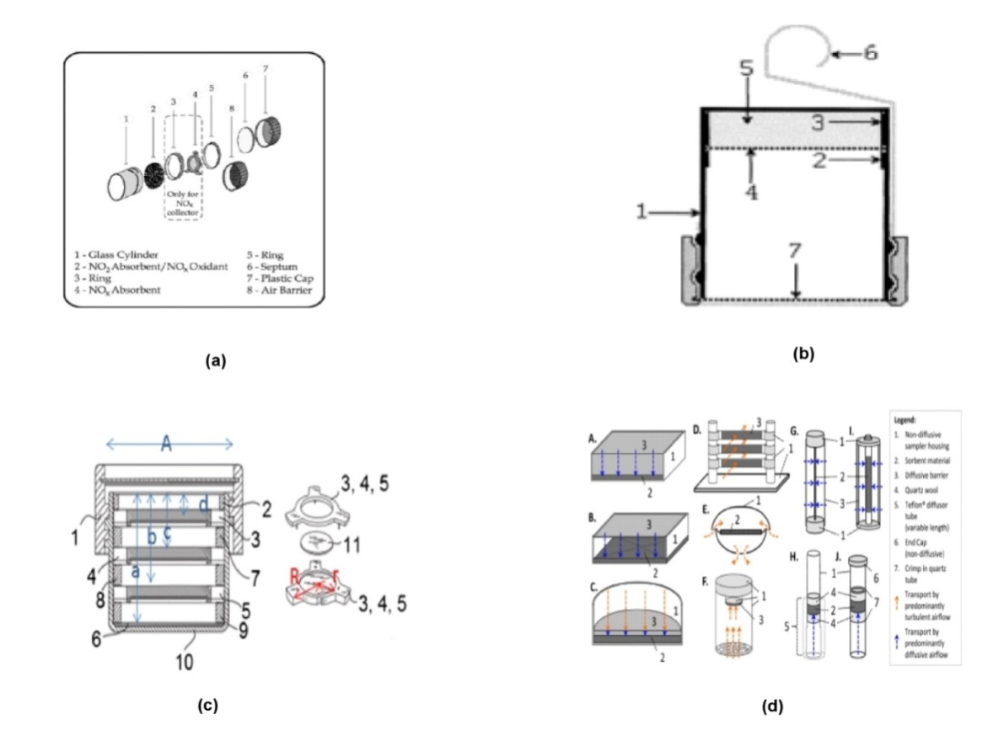
Figure 2.(a): Exploded scheme of Analyst NO₂ and NO_{x} passive samplers [62(a)].(b): Structure of the 'Analyst' sampler, improved by Bertoni et al.; [66(a)] for BTX analytes/pollutants.(c):Exploded scheme of the multi-pollutant sampler, according to the literature [67].(d):. Schematics of existing PASs (Passiveair samplers) for GEM (gaseous elemental mercury), according to the reference [68, and references cited therein].
Particulate Matter and portable sensors for solid pollutants. Lower cost portable Particulate Matter (PM) sensors can be identified according to the mechanism involved to detect the concentrations of particulate matter. Most of these sensors are based on the physical light scattering principle. General overview on the instrument performances, based on light scattering, can be found in a number of review articles [69] and books. Figure 3(a) shows some of the commercially available cheap PM monitoring tools, exhibiting current and commercial prices, ranging from 10 to 1000 EUR. They are movable and portable devices, eligible for in situ measurements, especially useful for the analytical diagnosis of the unmovable Art Work surfaces and objectives. The design and fabrication show excellent results obtained by exposing the sensor to PM concentrations, mainly come from to the tobacco smoke and the diesel exhaust. Its small size (25 mm × 21 mm × 2 mm) guarantees an easy integration into a portable platform for PM fine (PM_{2.5} and PM_{1.0}) fractions monitoring. The sensor has an air-microfluidic circuit that separates the particles by size (virtual impactor) and then transports and deposits the selected particles using thermophoretic precipitation onto the surface of a microfabricated mass-sensitive Film Bulk Acoustic Resonator (FBAR, Figure 3b), reported in reference [70], in details. The mass-loading of the FBAR causes a change in its resonant frequency, and the rate of the frequency change corresponds to the uptake particle concentration. Experimental results demonstrate the performance of this sensor for measuring PM mass, having a high sensitivity of 2 g/m³, with up to 10 min of integration time.
Justin P. Black, et al.; [71], report about a miniaturized Micro Electro-Mechanical Systems (MEMS) particulate matter (PM) monitor that employs the deposition of particulates from a sample stream onto a 1.6 GHz piezoelectric thin-film bulk acoustic wave resonator (FBAR), by means of thermophoresis. The quantitative determination of the mass deposited is carried out by measuring the resonant frequency shift of a Pierce oscillator. Real-time measurements, made in an environmental chamber over several weeks, show excellent correlation with the responses of other commercial aerosol instruments. An added mass of 1pg could be detected, and the Limit of Detection (LOD) is 18 μg/m³. Themonitor weighs 114 g, has a volume of approximately 245 cm³, consumes less than 100 mW, and would cost less than $100 USD in small quantities. Further investigations will focus on the miniaturization of the MEMS/PM sensor and its integrationin cell-phone wireless based Information and Communication Technology (ICT) prototypes. These latter, could be very promising for the detection of the PM present in archives/libraries before their deposition on the art work surfaces. Instead, a new generation of tattoo sensors could represent an innovative approach, to detect PM and other gaseous pollutant, directly adsorbed on Cultural Heritage surfaces. This latter sensor tattoo prototypes, are widely described in the next paragraph.
Miniaturized Tattoo Sensors as new generation of portable in contact tools. Recently, Wang et al.; [72] discover and develop a new generation of the non-invasive and contact portable sensors, labelled as tattoo sensor devices (Figure 3c). Wang, et al.; [72] describe the production, characterization and final application of temporary transfer tattoo-based sensors, equipped with a miniaturized wearable wireless transceiver (Figure 3c), for real-time monitoring of several ions and molecules, useful to detect in health care field applications. Among these analytes, there are several molecular probes interesting to quantify in CH restoration field, because they are also involved in the deterioration processes, responsible for the damages observed on Art Work objectives and surfaces. For example, pH (related to the activity of the proton, H⁺, and labelled as: a_{H+}) and pI (related to the activity of several different cations, as: Na⁺, Ca²⁺, K⁺, etc.;) can be selectively measured, assembling the ISE (Ion Selective Electrodes), as described in literature [73]. These electrodes are fabricated by coupling the screenprinting and tattoo-transfer technologies with solid-contact conventional ISE [73]. Printing technologies could be realized on different textile supports, as: animal (wool), plant (cotton; cellulose paper; etc.), or synthetic (nylon, polyester) substrata/support. They possess inert properties and yield stable operation for longer interval time. For example, the possibility to monitor the pH changes, directly on the deteriorated ancient paper manuscripts and damaged parchments (containing iron gall inks on cellulosic or membranaceous materials), before and after the restoration/conservation treatments, is fundamental for restorers and conservator scientists to develop non-invasive and non-destructive remediation strategies on the Original Art Work surfaces. Furthermore, the possibility to detect on CH samples, the amount of Na⁺, Ca²⁺, K⁺ provides a quantitative estimation of the inorganic salts concentration, mainly responsible for the efflorescence/sub-florescence contamination damages, when water delivers the electrolytes, provoking the precipitation of white solid powder (responsible for superficial deposits, on art work surfaces, better known as efflorescence phenomena, and/or internal deposits in the bulk of art work objectives, defined as sub-florescence phenomena, according to http://www.icr.beniculturali.it/ ). Among these environmental ions, NH₃/NH₄⁺ ionic couple is very important to detect for CH and Wang et al.; [74] also develop an ammonium based sensors tattoo, suitable for the quantification of ammonia/ammonium salts. The quantitative analysis detects ammonium concentration in the range from 10⁻⁴ M to 10⁻¹ M. The tattoo responses for varying ammonium levels was measured and the tattoo devices responded in a near-Nernstian response with minimal hysteresis. Repeated mechanical deformations of the sensor showed negligible effects on the sensor tattoo responses. This tattoo prototype could be eligible for the monitoring of the deposited ammonium salts (mainly present as environemental ammonium sulphate, (NH₄)₂SO₄) on Art Work surfaces, when delivered by the fine particulate matter (present in troposhere in winter and in summer seasons), according to Allegrini et al.; [75] field campaign investigation. In fact, Allegrini et al.; [75] demonstrate that (NH₄)₂SO₄ results the major chemical component of the Fine Particulate Matter during two field campaigns, caried out on 2007, at Beijing (China), as part of CAREBEIJING (Campaigns of Air Quality Research in Beijing and Surrounding Region). The ammonium tattoo sensor prototype seems to be eligible for the analytical diagnosis of CH damages, directly carried out on the art work objetive surfaces, in contact mode. The procedure also results compltely non invesive for CHs.

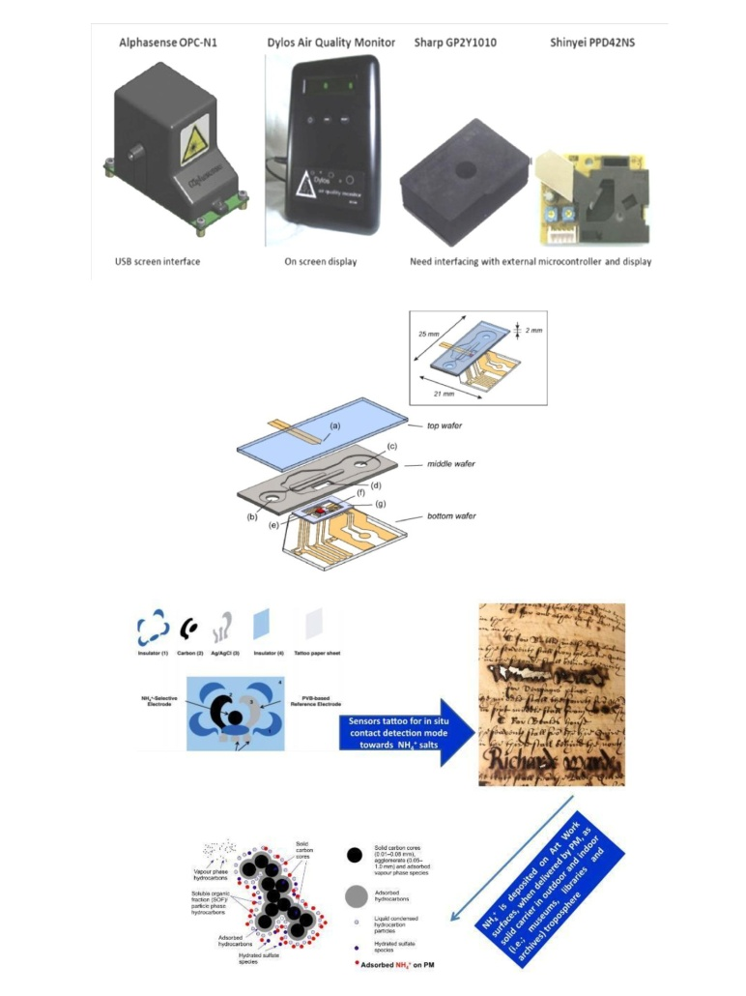
Figure 3.(a): Examples of PM small inexpensive monitors and sensors, as reported by reference [69]. (b): Exploded CAD drawing of the three-wafer stacked MEMS PM sensor. The inset shows a CAD drawing of the assembled sensor, according to the reference [70]. (c): Layer-by-layer fabrication of the potentiometric tattoo sensor, as reported by Wang et al.; [74] in literature. This potentiometric sensor tattoo could be suitable for the detection of deposited ammonium salt (on the indoor Cultural Heritage surfaces and Art Work objectives), delivered by the Particulate Matters (PMs), come from the troposphere.
In addition, it is very useful to underline that the same tattoo sensor prototypes could be also assembled as a long-term reserve of restoration/consolidation chemical agents, properly release on art work surfaces, only when ΔpH, Δμ (where μ represents the ionic strength of the enevironment) modifications, significantly occur on the damaged historical surfaces (Scheme 2). These latter prototypes represent new tattoo based actuators, suitable for in situ controlled restoration, cleaning, consolidation and conservation of damaged and deteriorated CHs, activated when the chemical-physical and biochemical fetaures of the aged historical surfaces consistently changes (stimulating the controlled release of the restoration agents,spontaneously). The great opportunity to combine smart tattoo devices and highly performance tattoo actuators offers a smart solution for in situ monitoring of the conservation status of the unmovable and untangible art work objectives, and, at the same time, provide a great advantage to in loco restore art work surfaces. The final and complete integration of tatto devices, in a multi-parameter sensors array, contribute to develop a new proof of concept for the mobile laboratory, eligible to carry out both strategies on CH samples, as: in loco diagnosis and in situ restoration. Finally, to conclude the first section of this manuscript, a comparative study concerning the analytical parameters and performances exhibited by all the sensor/actuator prototypes are summarized on Table 1. This summary is important in order to select the best practice to carry out an exhausistive diagnosis of the damages and a complete air quality control of the indoors or outdoors areas dedicated to the preservation of CHs. This right monitoring of the conservation status of CHs, represents the main point to induce restorers and conservator scientists to choice the best strategies for restoration, consolidation, conservation and prevention of the art work objectives (for longer time).
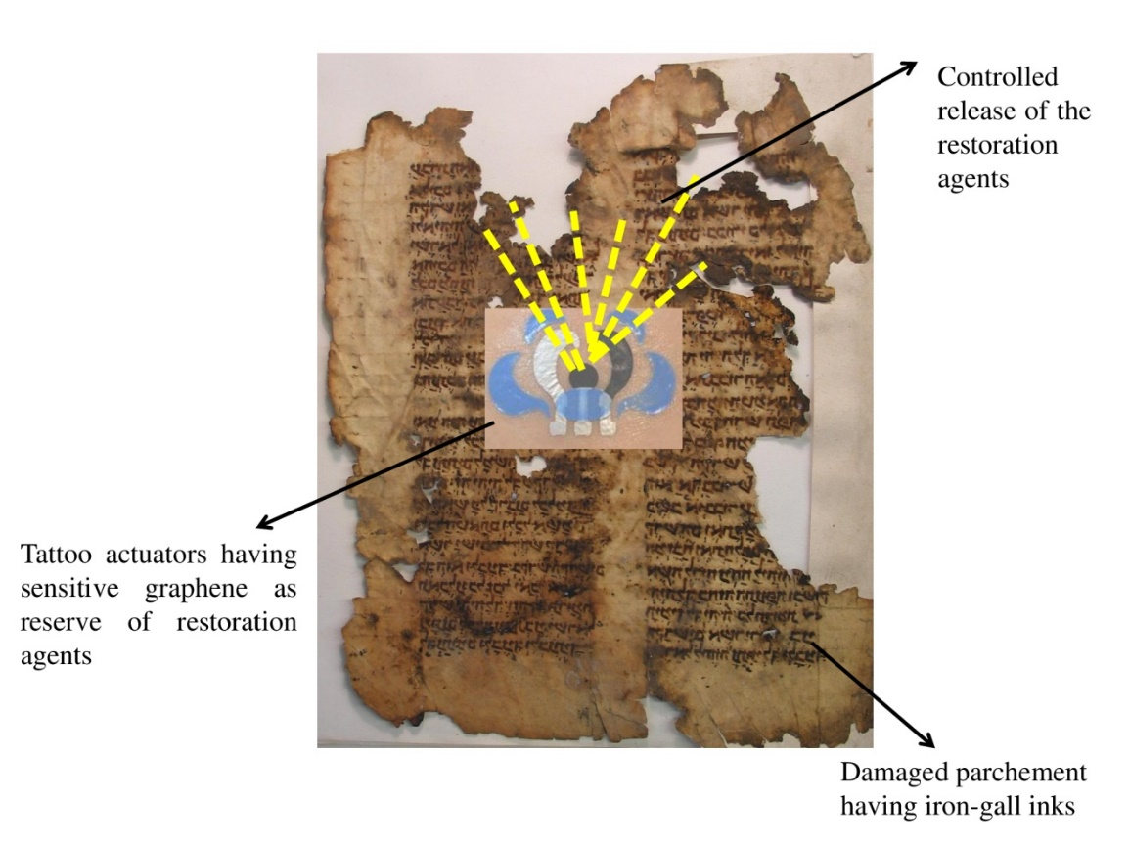
Scheme 2. This cartoon (assembled by the authors of the manuscript) represents the main idea of the tattoo actuator [74] mechanism on CH sample, based on functionalized graphene nanomaterial, which act as reserve of restoration/consolidation chemical agents, suitable to release the selective agents in controlled way, on damaged Art Work surfaces. These latter samples (i.e.; damaged paper and parchment samples) provide the right clock for the modulated releasing of restoration agents, depending on the ΔpH, Δμ and other modification of chemical-physical parameters, induced by inner and/or outer deterioration events.
Table 1. Comparison in terms of the sensitivity for the most performing sensors described in the review, suitable for CHs.
Portable/movable Sensors | Sensitive nano material layers | Sensitivity parameter | References
Miniaturized optical sensors humidity  Fabry–Perot resonator | reduced graphene oxide | 0.22 dB/% RH | [50]
Miniaturized capacitive sensors humidity | graphene oxide | up to 37800% | [54]
Miniaturized pH-transducers | acrylic acid and iso octylacrylate, on the 2826MB ((Fe₄₀Ni₃₈Mo₄B₁₈) sensitive surface | 0.6%/pH | [59]
Passive samplers (PAS)  NO₂  SO₂ | filter of carbon paper coated by 3.0 mM Na₂CO₃/0.3 mM NaHCO₃, aqueous solution | 5μg/m³ (NO₂)  10μg/m³ (SO₂) | [63]
Particulate Matter and portable sensors for solid pollutants  Micro-fabricated mass-sensitive Film Bulk Acoustic Resonator (FBAR) | Filter-pack systems | 2g/m³ | [70]

3. II section: the mobile Laboratory integrated with ICT/IoT for Cultural Heritage
Conventionally, miniaturized and portable instruments are very well known and applied mainly for “in situ” diagnosis of the environmental damages, present on Art Work surfaces. Recently, Sciutto et al. [76] develop new systems apply lateral flow immunoassays to quantify two proteins (ovalbumin and collagen) in Cultural Heritage surfaces and objectives. The new portable biosensors are equipped with chemiluminescent and colorimetric detectors. The chemiluminescent system displayed the best analytical performances, especially in terms of lower limits of detection, a wide linear range of concentration, and a high sensitivity than that exhibited by the colorimetric detection system. To miniaturize the device, a disposable cartridge was realized ad hoc for in situ specific applications. The results highlight the enormous potential of these inexpensive, easy‐to‐use, and minimally invasive diagnostic tools for conservators in the cultural heritage field.
The great opportunities to integrate portable sensors in the Smart Wireless Sensor Network (WSN) seems to be eligible for the Heritage scenarios protection. WSNs guarantee specificity, autonomy, self-configurability, lasting lifetime, and mobility of the resulting portable apparatuses, suitable for in situ monitoring of CH. However, their services, protocols, and architectures support new issues for protecting all the outdoor and indoor cultural heritage surfaces. According to these considerations, Rodríguez-Sánchez et al.; [77], provide a new integrated modular system, consisting of three elements: a WSN, a “Central System,” and a novel platform named “Local Node Gateway.” It exhibits the coexistence of different wireless technologies in order to provide sensor functionalities, actuation for “in situ” restoration/consolidation, processing and communication performances, as described below, in details.
(a) Wireless Sensor Network (WSN). The radio frequency communication is suitable for the monitoring of the Cultural Heritage environments, because is not limited by line-of-sight and the current technology allows implementation of low-power radio transceivers. ZigBee and Bluetooth are some standard protocols for short-range wireless communications. Especially, mobile phones and electronics devices adopt Bluetooth to send documents, files, images or documents for information of art work objectives (especially before and after restoration/conservation treatments and procedures). The same authors [77] propose a WSN based on MICAz modules by Crossbow. They use a MPR2400CA and MTS400 as transmission nodes, having different modules with several parameters, useful for the establishement of the conservation status of CHs, such as: temperature, humidity, pressure, luminosity, and two-axis acceleration. This receptor node, based on MICAz and MIB510 boards; could allow to add new chmical sensors to detect additional parameters, as CO₂ and other gaseous molecular pollutants and particulate matter pollutants (PMs, reported previosuly in the text).
(b) Central System (CS). CS provides storage in a database, security and user interface to access to the environmental information, with capabilities of remote monitoring and storage in any place and any time. “Central System” consists of a web server, a database and a user interface. The server continuously receives data from the local environment to be processed and analyzed in real time. As the web interface, the same authors [77] have chosen Java. Java is a general-purpose, concurrent and multiplatform programming language. It accepts all the information from the environment using long-range wireless communication processes. These data are stored in the database using a web server and a database server, in order to perform environmental tasks. Considering that the environmental information is remotely monitored; some security mechanisms needs to be improved. A Firewall for protecting the resources of “Central System”, has been adopted by the authors, [77].This control is over client users and “Local node Gateway” tasks. It was implemented using a user registering method based on login and password to access into the system.
(c) Local Node Gateway (LNG). All the required functionalities are in the “Local Node Gateway” with a single M2M GSM/GPRS device, as described in literature [78]. It has a processing and communication units, without external microprocessor and external embedded tools. It is designed in a modular, flexible, scalable and adaptable mode in order to provide sensing for analytical diagnosis, actuating for in situ remediation, long range communication and broadcasting information to users. The advantages related to the power consumption, hardware platform size and cost, result three times better than other commercial systems. The proposed system it's already working at San Sebastian Church (Figure 4), Seville, Spain, since November 2008 [79]. The collected data are satisfactory to end users, as restorers and conservator scientists, who studied the experimental results to select the best strategies to preserve Cultural Heritage surfaces and objectives. This working approch could be improved combining the described technology with Internet services.
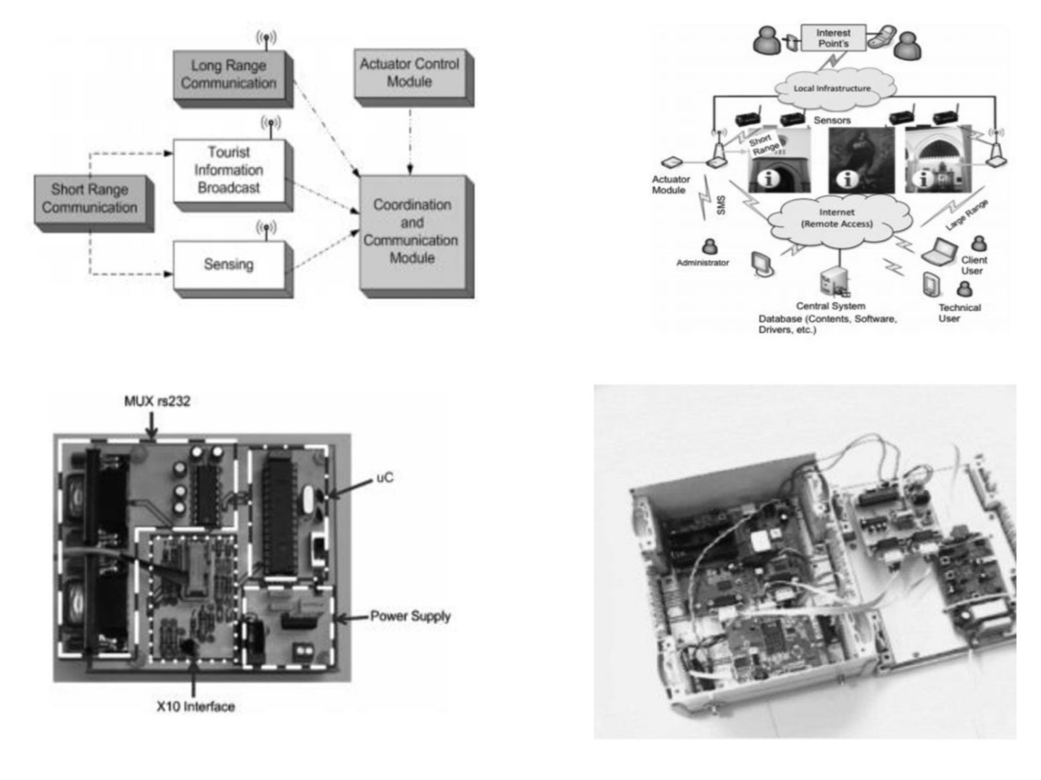
Figure 4.(a):Block diagram for “Local Node Gateway”. (b):Example of deployment at San Sebastian Church, Seville, Spain..(c):Multiplexing board for prototype v.30 for mobile sensor array. (d):Internal picture of prototype v3.0 for portable laboratory, suitable for un-movable CH and Art Work objectives. All these pictures are related and described to the reference [77 and reference cited therein].
For this purpose, the rapid development of Information and Comunication Technology (ICT) and the growth of the Internet (Internet of Things, IoT) through high speed networks, network environments have even been changed from office oriented environments based on business industries and public institutions to the interconnection of digital electronics in home networks. Home network based applications are very diverse and the remote monitoring and control areas have been studied. Moreover, owing to the rapid growth of mobile technology, high performance smartphones are widespread and in increasing cases are utilized as a terminal devices. Internet of Things (IoT) is a global infrastructure for the information society, enabling advanced services by interconnecting (physical and virtual) things based on existing and evolving inter-operable ICT [80]. Internet of Things (IoT) computing applied to the Art Work objectives domain is an innovative discipline which consists of the application of smart sensor and actuator technologies on cultural, historical and archeological areas [81], strongly related to the development of systems able to be pervasive and ubiquitous with the definitive goal of re-thinking such spaces [82]. IoT paradigm constitutes a powerful tool to enhance people fruition and enjoyment of such spaces; thanks to ICT technologies, a cultural object can be effectively “dressed” of its context and juxtaposed into it, as reported in literature [83]. Intelligent and pervasive environments are characterized by a great number of devices and sensors/actuators that develop continuously and capture enormous amounts of data [84]. The Cultural Heritage domain represents a space where exchanged and produced data can be opportunely exploited by a set of applications and services in order to transform a static space into a “smart” environment [85]. By means of innovative technological applications and location-based services it is possible to shorten the distance between cultural spaces and their visitors, nowadays determined by the purely aesthetic and essentially passive fruition of cultural objects. Technology can become a mediator between visitors and fruition, an instrument of connection between people, objects and spaces to create new social, economic and cultural opportunities [86-88]. Today is no doubt that Internet of things is the next evolution of Internet: as Internet 2.0 has been represented by the world of social networking [89], relationships that happen in the global net and become shared information, Internet 3.0 is going to be the extension of Internet to the world of physical objects or things [90]. The challenge is to permit to the things to participate to a new extended social network and, then, to interact with other objects and with humans [91-93]. Also, we are going to enter in the era of ubiquitous computing and of Big Data collected by smart and advanced sensors/actuators[94-96]. Big numbers have a counterpart in the budgets of ICT companies and research institutes. The first role of ICT is to transmit intelligence to things, the objects of our daily life. Gartner, the world’s leading information technology research and advisory company, estimates that in next few years 26 billion of objects will be connected [97], many of them in a global infrastructure. A report of ABI research considers this expectation cautious and expects about 30 billion of new physical connections. IoT refers to network connection of physical objects, using sensors, actuators and other control system tools and devices [98]. These components are able to register and transmit information about these objects. This amount of data can be analyzed to optimize products, services and operations. The new intelligent things, with decisional capabilities, will have tremendous energy saving potential for personal use (domotics and smart-home) and also, in a collective dimension (smart-city, smart-grid, protection of critical infrastructures) [99].This massive number of sensors, actuators and other devices will be a powerful source of data; they have to be filtered, coordinated, and elaborated. This new scenario will define a new Information and Communication Technology. The Big Data revolution, exploded with the ever–increasing diffusion of social networks, will be enforced with the arrive of the IoT: for the first time, companies will be able to discover new opportunities studying, in a more effective manner, the behaviours of their customers [100] and end users. They will be able to evaluate the perceptions of their brands, services and products, especially when restorers and conservator scientists need to compare and to share the results concerning the performances of new products and chemical agents, dedicated to restoration and conservation of original art work objectives. In this sense, IoT represents a new paradigm in the world of ICT that is involving vendors, service providers, system integrators and academic research centres. The new molecules of this new eco-system that is going to born are sensors/actuators [101] and movable devices. There is an high request for new ones in terms of power, precision and characteristics of captured data. So, IoT will open new scenarios in terms of physical contexts for new applications. One of these contexts is represented by mobile laboratories (i.e. labs). The reference architecture [102] consists of a physically constrained environment, a mobile room/laboratory, that can be transported. Inside this laboratory thousands of heterogeneous sensors/actuators can be activated to analyze critical objects, where measurements are to be extremely precise, fast and repeated several times (for reproducibility test).
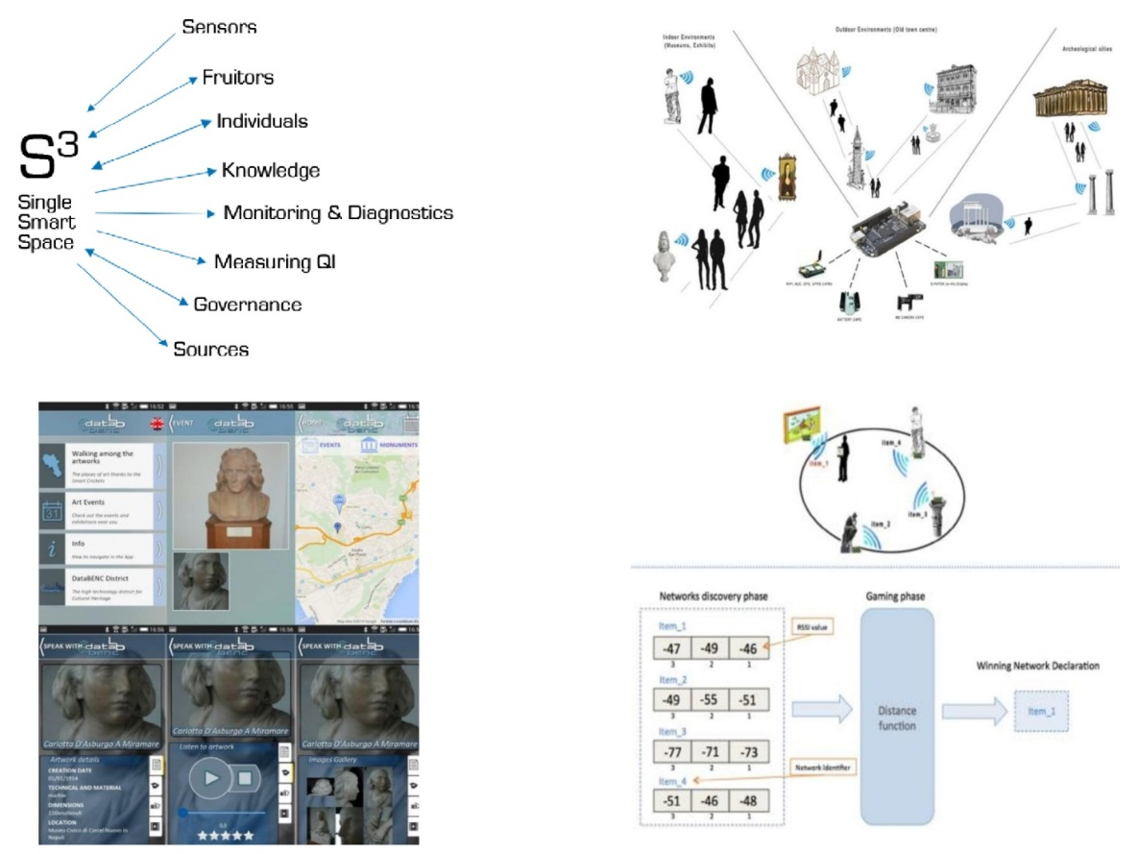
Figure 5.(a): The single smart space – S³ model. (b): The environments, both indoor and outdoor, where deploying the smart cricket sensors. (c): The main screens of the mobile application. All these pictures are related and described to the reference [82].
At the state of the art, there are some solutions about the fabrication of new portable Lab, completely dedicated to the diagnosis of damaged cultural heritage. Non-invasive mobile NMR (Nuclear Magnetic Resonance spectrometry) [103] and Laser-based systems [104] for the structural diagnostic of artwork; non-destructive tools for in situ micro analysis assays [105] of cultural heritage materials and finally MOLAB, a Mobile Laboratory for in situ non-invasive studies in arts and archaeology [106]. MOLAB is equipped with an array of state-of-the-art portable and non invasive instruments for both point and imaging analyses, for examples. The spectroscopic point techniques in MOLAB, are: XRF (X-Ray Fluorescence), micro-Raman, mid-FTIR (Fourier Transform Infrared spectroscopy), near-FTIR, UV-vis reflectance, UV-vis fluorescence, TCSPT (Time correlation single photon counting for fluorescence lifetime measurements). Until now, there are not portable/mobile apparatuses, devoted to in situ restoration and preservation of damaged art work surfaces, but the current movable labs work only in diagnosis of CH damages.
The new proof of concept, concerning a mobile Lab also equipped by miniaturized actuators could represent a future challenge, in CH. Especially, the raise of nanomotors, nano machineries and nano propellers could be eligible for in situ remediation, converting their chemical energy into their mechanical cleaning effects, on art work surfaces. For this purpose, miniaturized actuators could be integrated in micro-chip systems, combined with the wireless smart transmission of the signals, for fast communication technologies. For multi-sensors and multi-actuators systems, with a high number of sensors and actuators, coordinated via an intelligent device, the Research has not yet defined methodological solutions to be applied for data analysis [107]. In this context, the main requirements are the precision and the synchrony between sensors and actuators, coordinated by an evaluator that receives multi-sources data. Other requirements are real time reconfiguration of all devices and real time coordination between data capture tools and data analysis tools [108]. Given the needs of new precision levels, new approaches have initiated in terms of learning theories and data analysis tools. Traditional techniques of artificial intelligence have been also stressed in this direction. These efforts are going to converge to a new interdisciplinary approach to the machine learning, where data flows come from multiple and heterogeneous sources [109]. The goal is to forecast the presence of hidden factors, starting from physical, biased, evidences. Keywords in this new approach are casual analysis based on ordered sets of data or trajectories. New mathematical tools for data manipulation are going to emerge. Experimental results are relative to many sector of human knowledge [110], from bio-informatics and analysis of DNA, to forensics, to anomaly detection in information security, to the cooperative evolution of systems in biology and other cooperative contexts. New advanced engines for timed and spatially referenced data will appear and will be used to recognize and evaluate in real time what is happening in critical environments, where strong qualitative results are expected.

4. Conclusions
This review focus on new portable and movable smart sensors, mainly based on miniaturized devices suitable to perform “in situ” investigation of the conservation status of CHs. The new portable devices offer several advantages, as: 1) the in situ diagnosis of un-tangible and immovable cultural heritage surfaces and objectives; 2) the great opportunity to in situ restore and preserve Art Work surfaces without damages, considering their non-invasiveness towards materials used in the field of cultural heritage; 3) the great opportunity to collect big data systems, all interdisciplinary information, thanks to the ICT and IoT new generation technologies, necessary to rapidly spread information among end users of original cultural heritage objectives.
The highest analytical perfomances of these new portable devices, described in the review, mainly depend on selective and specific nanomaterials used for the assembly of integrated sensor and actuator systems. A powerful tool to design the multidisciplinary connection between new sensor array technologies and the high amount of useful information flowing from these smart portable devices (directed toward the end users) is represented by IoT and ICT emerging technologies. Especially IoT systems cover the fundamental role of connector between the chemical-physical, biochemical world and the world of information, in order to amplify the knowledge but also the enjoyment, in presence of Cultural Heritage and Art Work areas, objectives and historical surfaces.
Sensors, actuators, smart and selective nanomaterials, ICT and IoT are all suitable tools for the assembly of new concept of mobile/portable Laboratory, extremely useful for “in situ” diagnosis and “in loco” remediation/restoration of CHs and Archeological places.
Acknowledgments: This work was supported by grant Smart Campus Project (CUP E82I15000980002). The authors would like to thank Dr. I. Allegrini (Director for 22 years, from 1986 through 2008 of the Institute for Atmospheric Pollution of the Italian National Research Council, CNR Roma, Italy. Prof. Ivo Allegrini is recognized as one of the world’s leading experts in air pollution and environmental issues) for scientific support and technical assistance, concerning the monitoring and capturing based devices, dedicated to the analysis of the atmospheric environmental pollutants.
Author Contributions: Dr. Federica Valentini and Dr. Andrea Calcaterra wrote the manuscript and assembled the Figures/Tables. Prof. M. Talamo led the preparation of the manuscript and contributed to editorial modifications of the overall text.
Conflicts of Interest: The authors declare no conflict of interest.
References
  - Rittersma, Z.M. Review: Recent achievements in miniaturised humidity sensors—a review of transduction techniques, Sensors and Actuators A: Physical 2002, 96, 196-210.
  - Lung-Tai, Chen; Chia-Yen, Lee; Wood-Hi, Cheng MEMS-based humidity sensor with integrated temperature compensation mechanism, Sensors and Actuators A: Physical 2008,147, 522-528.
  - (a): Torsi, L.; Dodabalapur, A.; Sabbatini, L.; Zambonin, P. G. Multi-parameter gas sensors based on organic thin-film-transistors, Sensors and Actuators B: Chemical 2000,67, 312-316. (b): Prosek, T.; Kouril, M.; Dubus, M.; Taube, M.; Hubert, V.; Scheffel, B.; Degres, Y.;Jouannic, M.;Thierry, D. Real-time monitoring of indoor air corrosivity in cultural heritage institutions with metallic electrical resistance sensors, Studies in Conservation 2013 ,58, 117-128. (c): Grøntoft, T.;Odlyha, M.; Mottner, P.; Dahlina, E.; Lopez-Aparicio, S.; Jakiela, S.; Scharff, M.; Andrade, G.; Obarzanowski, M.; Ryhl-Svendsen, M.; Thickett, D.; Hackneyi, S.;Wadumj, J. Pollution monitoring by dosimetry and passive diffusion sampling for evaluation of environmental conditions for paintings in microclimate frames, Journal of Cultural Heritage 2010,11, 411-419.
  - Proietti, A.; Leccese, F.; Caciotta, M.; Morresi, F.; Santamaria U.; Malomo, C. A New Dusts Sensor for Cultural Heritage Applications Based on Image Processing, Sensors 2014, 14, 9813-9832.
  - Albertano, P.; Bruno, L.;Bellezza, S. New strategy for the monitoring and control of cyanobacterial films on valuable lithic faces, Plant Biosystems 2005,139,311–322.
  - (a): Horváth, R.; Pedersen, H. C.; Skivesen, N.; Selmeczi, D.; Larsen, N. B.;Optical waveguide sensor for on-line monitoring of bacteria, Opt. Lett. 2003, 28, 1233-1235. (b): Ong, K.G.; Wang, J.; Singh, R.S.; Bachas, L.G.; Grimes, C.A. Monitoring of bacteria growth using a wireless, remote query resonant-circuit sensor: Application to environmental sensing, Biosensors and Bioelectronics 2001,16, 305-312. (c): Wang, L.; Zhao, W.; O'Donoghue, M. B.; Tan, W. Fluorescent Nanoparticles for Multiplexed Bacteria Monitoring, Bioconjugate Chem. 2007,18, 297–301.
  - (a): Liu, H.; Darabi, H.; Banerjee,P.; Liu, J. Survey of Wireless Indoor Positioning Techniques and Systems, IEEE Transactions on Systems, Man, and Cybernetics, Part C (Applications and Reviews) 2007, 37, 1067-1080. (b): Salthammer, T.; Mentese, S.; Marutzky, R. Formaldehyde in the Indoor Environment, Chem. Rev. 2010, 110, 2536–2572. (c): Wan, Z. G.; Tan,Y. K.; Yuen, C. Review on energy harvesting and energy management for sustainable wireless sensor networks, IEEE 13th International Conference on Communication Technology, Jinan 2011, 362-367.
  - (a): Ardizzone, E.; La Cascia, M.; Lo Re, G.; Ortolani, M. An integrated architecture for surveillance and monitoring in an archaeological site, VSSN '05 Proceedings of the third ACM international workshop on Video surveillance & sensor networks 2005, 79-86. (b): Caggianese, G.; Neroni, P.; Gallo, L. Natural Interaction and Wearable Augmented Reality for the Enjoyment of the Cultural Heritage in Outdoor Conditions, International Conference on Augmented and Virtual Reality, AVR Augmented and Virtual Reality 2014, 267-282. (c): Gleue, T.; Dähne, P.; Design and implementation of a mobile device for outdoor augmented reality in the archeoguide project, VAST '01 Proceedings of the conference on Virtual reality, archeology, and cultural heritage 2001, 161-168.
  - (a): Alemdar, H.; Ersoy, C. Wireless sensor networks for healthcare: A survey, Computer Networks 2010, 54, 2688-2710. (b): Mukhopadhyay, S. C. Wearable Sensors for Human Activity Monitoring: A Review, IEEE Sensors Journal 2015,15, 1321-1330.
  - (a): McNab, T.J.; James, D.A.; Rowlands, D. D. , iPhone sensor platforms: Applications to sports monitoring, Procedia Engineering 2011,13, 507-512. (b): Ray, P. P.Generic Internet of Things architecture for smart sports, Communication and Computational Technologies (ICCICCT) 2015, 405-410.
  - (a): Wang, N.; Zhang, N.; Wang, M. Review: Wireless sensors in agriculture and food industry, Recent development and future perspective, Computers and Electronics in Agriculture 2006, 50, 1-14. (b): Ruiz-Garcia, L.; Lunadei, L.; Barreiro, P.; Robla, J. I. A Review of Wireless Sensor Technologies and Applications in Agriculture and Food Industry: State of the Art and Current Trends, Sensors 2009, 9, 4728-4750.
  - (a): Kularatna, N.; Sudantha, B. H. An Environmental Air Pollution Monitoring System Based on the IEEE 1451 Standard for Low Cost Requirements, IEEE Sensors Journal 2008, 8, 415-422. (b): Hart, J. K.;Martinez, K. Environmental Sensor Networks: A revolution in the earth system science? Earth-Science Reviews 2006, 78, 177-191.
  - Chemical Sensors Market (By Type: Catalytic Bead, Electrochemical, Optical Sensor, and Others; By End-User: Medical, Oil & Gas, Industrial, Automobile, Environment Monitoring, and Others; By Geography: North America, Europe, Asia-Pacific and RoW) Global Scenario, Market Size, Outlook, Trend and Forecast, 2015-2024
  - (a): Manz, A.; Widmer, H.M. Miniaturized total chemical analysis systems: A novel concept for chemical sensing, Sensors and Actuators B: Chemical 1990,1, 244-248. (b): Torsi, L.; Magliulo, M.; Manoli, K.; Palazzo, G. Organic field-effect transistor sensors: a tutorial review, Chem. Soc. Rev. 2013, 42, 8612-8628. (c): Guth, U.; Vonau, W.;Zosel, J. Recent developments in electrochemical sensor application and technology- a review, Meas. Sci. Technol. 2009,20,1-14.
  - (a): Shabani, R.; Cho, H. J. Nanomaterials in Actuators A Reviews in Nanoscience and Nanotechnology 2012, 1, 85–102. (b): Kong, L.; Chen, W. Carbon Nanotube and Graphene‐based Bioinspired Electrochemical Actuators, Advanced Materials 2014, 26, 1025–1043.
  - (a): Llobet, E. Gas sensors using carbon nanomaterials: A review, Sensors and Actuators B: Chemical 2013, 179, 32-45. (b): Ipe, B. I.; Yousaf, K.; Thomas, K. G. Functionalized goldnanoparticles as phosphorescent nanomaterials and sensors, J. Am. Chem. Soc. 2006, 128, 1907-1913. (c): Peralta-Videa, J. R.; Zhao, L.; Lopez-Moreno, M. L.; La Rosa, G.; Hong, J.; L.Garde-Torresdey, J. Nanomaterials and the environment: a review forthe biennium 2008-2010, Journal of Hazardous Materials 2011, 186, 1-15.
  - (a): Applications of Nanomaterials in Sensors and Diagnostics, Adisorn Tuantranont Editor, Springer Heidelberg New York Dordrecht London ISSN 1612-7617; ISBN 978-3-642-36024-4, 2013. (b): BelBruno J. J. Nanomaterials in Sensors, Nanomaterials 2013, 3, 572-573.
  - Fratoddi, I.; Bearzotti, A.; Venditti, I.; Cametti, C.; Russo, M.V. Role of nanostructured polymers on the improvement of electrical response-based relative humidity sensors, Sensors and Actuators B: Chemical, 2016, 225, 96-108.
  - Shrivastava, S.; Jadon, N.; Jain, R. Next-generation polymer nanocomposite-based electrochemical sensors and biosensors: A review. Trends in Analytical Chemistry, 2016, 82,55-67.
  - Malkiat, S. J.; Lewis E. J. Understanding Nanomaterials, Second Edition, Editore CRC Press, ISBN 1482253240, 9781482253245, 2018.
  - Guo, Y.-G.; Hu, J.-S.; Wan, L.-J. Nanostructured Materials for Electrochemical Energy Conversion and Storage Devices, Advanced Materials 2008, 20, 2878-2887.
  - Minnich, A. J.; Dresselhaus, M. S.; Ren, Z. F.; Chen,G. Bulk nanostructured thermoelectric materials: current research and future prospects, Energy Environ. Sci, 2009, 2, 466-479.
  - Rogers, J. A; Someya, T.; Huang, Y. Materials and mechanics for stretchable electronics, Science 2010, 327, 1603-1607.
  - Amjadi, M.; Pichitpajongkit, A.; Lee, S.; Ryu, S.; Park, I. Highly Stretchable and Sensitive Strain Sensor Based on Silver Nanowire–Elastomer Nanocomposite, ACS Nano 2014, 8, 5154–5163.
  - Bae, S.; Kim, H.; Lee, Y.; Xu, X.; Park, J.-S.; Zheng, Y.; Balakrishnan, J.; Lei, T.; Kim, H. R.; Song, Y.; Kim, Y.-J.; Kim, K. S.; Ozyilmaz, B.; Ahn, J.-H.; Hong, B. H.; Iijima, S. Roll-to-roll production of 30-inch graphene films for transparent electrodes, Nature Nanotechnology 2010, 5, 574-578.
  - Weber, C. M.; Eisele, D. M.; Rabe, J. P.; Liang, Y.; Feng, X.; Zhi, L.; Müllen, K.; Lyon, J. L.; Williams, R.; Vanden Bout, D. A.; Stevenson, K. J. Graphene-based optically transparent electrodes for spectroelectrochemistry in the UV-Vis region, Small 2010, 6, 184-189.
  - Ambrosi, A.; Pumera, M. 3D-printing technologies for electrochemical applications, Chem. Soc. Rev. 2016, 45, 2740-2755.
  - Carrilho, E.; Martinez, A. W.; Whitesides, G. M. Understanding Wax Printing: A Simple Micropatterning Process for Paper-Based Microfluidics, Anal. Chem. 2009, 81, 7091-7095.
  - Martinez, A. W.; Phillips, S. T.;Whitesides, G. M.; Carrilho, E. Microfluidic paper-based analytical devices (μPADs) are a new class of point-of-care diagnostic devices that are inexpensive, easy to use, and designed specifically for use in developing countries, Anal. Chem. 2010, 82, 3-10.
  - Camuffo, D.; Microclimate for Cultural Heritage Conservation, Restoration, and Maintenance of Indoor and Outdoor Monuments, Elsevier, New York Second Updated and Expanded Edition, 2013.
  - Bandodkar, A. J.; Wang, J. Non-invasive wearable electrochemical sensors: a review, Trends in Biotechnology 2014, 32, 363-371.
  - Bandodkar, A. J.; Jia, W.; Yardımcı, C.; Wang, X.; Ramirez, J.; Wang, Tattoo-based noninvasive glucose monitoring: a proof-of-concept study, J. Anal. Chem. 2014, 87, 394–398.
  - Harris, K.D.; Elias, A.L.; Chung, H.J. Flexible electronics under strain: a review of mechanical characterization and durability enhancement strategies, Journal of Materials Science 2016, 51, 2771-2805.
  - Miyamoto, A.; Lee, S.; Cooray, N. F.;Lee, S.; Mori, M.; Matsuhisa, N.; Jin, H.; Yoda, L.; Yokota, T.; Itoh, A.;Sekino, M.;Kawasaki, H.;Ebihara, T.; Amagai, M.;Someya, T. Inflammation-free, gas-permeable, lightweight, stretchable on-skin electronics with nanomeshes, Nature Nanotechnology 2017, 12, 907–913
  - Soonjae, P.; Jungwook, C.; Jongbaeg, Kim. Flexible, Transparent, Sensitive, and Crosstalk‐Free Capacitive Tactile Sensor Array Based on Graphene Electrodes and Air Dielectric, Advanced Electronic Materials 2018, 4, 1700427.
  - Rao, C. N. R.; Müller, A.; Cheetham A. K.; (Eds.). "The Chemistry of Nanomaterials: Synthesis, Properties and Applications" by: Wiley-WCH Verlag GmbH & Co. KGaA ISBN-13: 978-35273068622004
  - Electrochemistry of Nanomaterials Editors(s): Dr. Gary Hodes, ISBN:9783527298365, 2007
  - Chen, T.; Dai, L. Carbon nanomaterials for high-performance supercapacitors, Materials Today 2013, 16, 272-280.
  - Ariga K.; Mori, T.; Hill, J. P. Mechanical control of nanomaterials and nanosystems, Advanced Materials 2012, 24, 158-176.
  - Chelazzi, D.; Poggi, G.; Jaidar, Y.; Toccafondi, N.; Giorgi, R.; Baglioni, P. Hydroxide nanoparticles for cultural heritage: consolidation and protection of wall paintings and carbonate materials, Journal of Colloid and Interface Science 2013, 392, 42-49.
  - Yang, S.; Chen, Y.-C.; Nicolini, L.; Pasupathy, P.; Sacks, J.; Su, B.; Yang, R.; Sanchez, D.; Chang, Y.-F.; Wang, P.; Schnyer, D.; Neikirk, D.; Lu, N. “Cut‐and‐Paste” Manufacture of Multiparametric Epidermal Sensor Systems, Advanced Materials 2015, 27, 6423–6430.
  - Amendola, S.; Lodato, R.; Manzari, S.; Occhiuzzi, C.; Marrocco, G. RFID technology for IoT-based personal health care in smart spaces. IEEE Internet of Things Journal 2014, 1, 144-152.
  - (a): Vuorinen, T.; Niittynen, J.; Kankkunen, T.; Kraft, T. M.; Mäntysalo, M. Inkjet-Printed Graphene/PEDOT:PSS Temperature Sensors on a Skin-Conformable Polyurethane Substrate. Scientific Reports 2016, 6, 1-8. (b): Vilela, D.; Romeo, A.; Sánchez, S. Flexible sensors for biomedical technology, Lab Chip 2016, 16, 402-408.
  - Caldara, M.; Colleoni, C.; Guido, E.; Re, V.; Rosace, G. Optical monitoring of sweat pH by a textile fabric wearable sensor based on covalently bonded litmus-3-glycidoxypropyltrimethoxysilane coating, Sensors and Actuators B: Chemical 2016, 222, 213-220.
  - (a):The Atlas of Climate Change Impact on European Cultural Heritage: Scientific Analysis and Management strategies, Edited by Sabbioni, C.; Brimblecombe, P.; Cassar, M. ISBN 9780857282835, 2012 .(b): De Santis, F.; Vazzana, C.; Menichelli, S.; Allegrini, I. The measurement of atmospheric pollutants by passive sampling at the Uffizi Gallery, Florence. Annali di Chimica 2003, 93, 45-53. (c): Urban Air Pollution Monitoring and Control Strategies, Editors: Allegrini, I.; DeSantis, F; (Eds.), ISBN 978-3-642-61120-91996.
  - (a): Scharko, N. K.; Berke, A. E.; Raff, J. D. Release of Nitrous Acid and Nitrogen Dioxide from Nitrate Photolysis in Acidic Aqueous Solutions. Environ. Sci. Technol. 2014, 48, 11991-12001. (b): Acker, K.; Febo, A.; Trick, S.; Perrino, C.; Bruno, P.; Wiesen, P.; Möller, D.; Wieprecht, W.; Auel, R.; Giusto, M.; Geyer, A.; Platt, U.; Allegrini, I. Nitrous acid in the urban area of Rome. Atmospheric Environment 2006, 40, 3123-3133.
  - (a): Chen, G. Y.; Lancaster, D. G.; Monro, T. M. Optical Microfiber Technology for Current, Temperature, Acceleration, Acoustic, Humidity and Ultraviolet Light Sensing, Sensors 2018, 18, 72- (b):
Correia, S. F. H.; Antunes, P.; Pecoraro, E.; Lima, P. P.; Varum, H.; Carlos, L. D.; Ferreira, R. A. S.; André, P. S. Optical Fiber Relative Humidity Sensor Based on a FBG with a Di-Ureasil Coating,Sensors (Basel), 2012, 12, 8847–8860.
  - Kumar, C.; Pattammattel, A.; Introduction to Graphene 1st Edition Chemical and Biochemical Applications, ISBN: 9780128131824, Imprint: Elsevier Published 12th August 2017
  - Gao, R.; Lu, D.-F.; Cheng, J.; Jiang, Y.; Jiang, L.; Qi, Z.-M. Humidity sensor based on power leakage at resonance wavelengths of a hollow core fiber coated with reduced graphene oxide, Sensors and Actuators B, 2016, 222, 618-624.
  - Lee, C.-Y.; Lin, C.-H.; Lo, Y.-M. Fabrication of a Flexible Micro Temperature Sensor for Micro Reformer Applications, Sensors 2011, 11, 3706-3716.
  - Thuau, D.; Abbas, M.; Wantz, G.; Hirsch, L.; Dufour, I.; Ayela, C.Piezoelectric polymer gated OFET: Cutting-edge electro-mechanical transducer for organic MEMS-based sensors,Scientific Reports 2016, 6, 38672-38680.
  - Santra, S.; Hu, G.; Howe, R. C. T.; De Luca, A.; Ali, S. Z.; Udrea, F.; Gardner, J. W.; Ray, S. K;. Guha, P. K.; Hasan, T. CMOS integration of inkjet-printed graphene for humidity sensing, Scientific Reports 2015, 5, 17374-17386.
  - Bi, H.; Yin, K.; Xie, X.; Ji, J.; Wan, S.; Sun, L.; Terrones, M.; Dresselhaus, M. S. Ultrahigh humidity sensitivity of graphene oxide, Scientific Reports 2013, 3, 2714-2721.
  - Rathi, K.; Pal, K. Impact of Doping on GO: Fast Response−Recovery Humidity Sensor, ACS Omega 2017, 2, 842−851.
  - Varghese, O. K. ; Grimes, C A. Metal Oxide Nanoarchitectures for Environmental Sensing, Journal of Nanoscience and Nanotechnology, 2003, 3, 277-293
  - Farahani H.; Wagiran, R.; Hamidon, M. N. Humidity Sensors Principle, Mechanism, and Fabrication Technologies: A Comprehensive Review, Sensors 2014, 14, 7881-7939.
  - Grimes, C. A.; Mungle, C. S.; Zeng, K.; Jain, M. K.;Dreschel, W. R.; Paulose, M.; Ong, K. G. Wireless Magnetoelastic Resonance Sensors: A Critical Review, Sensors 2002, 2, 294-313.
  - Cai, Q.; Jain, M.K.; Grimes, C. A. A wireless, remote query ammonia sensor. Sens Actuators B Chem. 2001, 77, 614-619.
  - Shen, W.; Zhang, Z.; Horikawa, S , Zhang, A ,Teng, J.; Mathison, L.C., Chin, B.A. Time domain characterization of magnetoelastic sensors: A pulse method for resonance frequency determination, The Review of Scientific Instruments 2010, 81, 084702-084709
  - De Santis, F.; Vazzana, C.; Menichelli, S.; Allegrini, I. The measurement of atmospheric pollutants by passive sampling at the Uffizi Gallery, Florence. Annali di Chimica, 2003, 93, 45-53. (b): De Santis, F.; Fino, A.; Vazzana, C.; Allegrini, I. Monitoring of atmospheric pollutants by passive sampling for the protection of historic buildings and monuments. Annali di Chimica 2001, 91, 759-765.
  - (a): De Santis, F.; Dogeroglu, T.; Fino, A.; Menichelli, S.; Vazzana, C.; Allegrini, I. Laboratory development and field evaluation of a new diffusive sampler to collect nitrogen oxides in the ambient air, Anal Bioanal Chem. 2002, 373, 901–907. (b): De Santis, F.; Allegrini, I.; Bellagotti, R.; Vichi, F.; Zona, D. Development and field evaluation of a new diffusive sampler for Hydrogen Sulphide in the ambient air, Anal. Chem. 2006, 384, 897-901.
  - (a): Allegrini, I.; Costabile, F. Proceeding of the international seminar urban air quality management 21-22 oct 2002. (b): De Santis, F.;Allegrini, I.;Fazio, M.C.; Pasella, D.; Piredda, R. Analytica Chimica Acta 1997, 346, 127-134.
  - (a): Hafkenscheid, T.; Fromage-Mariette, A.; Goelen, E.; Hangartner, M.; Pfeffer, U.; Plaisance, H.; De Santis, F.; Saunders, K.; Swaans, W.; Tang, Y.S.; Targa, J.; van Hoek, C.; Gerboles, M. European Commission Joint Research Centre Institute for Environment and Sustainability, EUR 23793 EN ISBN 978-92-79-12052-7 ISSN 1018-5593, 2009.
  - Costabile, F.; Bertoni, G.; De Santis, F.; Bellagotti, R.; Ciuchini, C.; Vichi, F.; Allegrini, I. Spatial Distribution of Urban Air Pollution in Lanzhou, China, The Open environmental pollution & toxicology journal 2010, 2, 8-15.
  - (a): Bertoni, G.; Tappa, R.; Allegrini, I. The internal consistency of the ‘analyst’ diffusive sampler. A long-term field test, Chromatographia 2001, 54, 653-657. (b): Bertoni, G.; Ciuchini, C.; Di. Palo, V.; Possanzini, M. Development of a Passive Sampler for Long-Term Measurements of Formaldehyde and Total Oxidants in Air, Chromatographia 2005, 61, 385-389.
  - Vichi, F.; Mašková, L.; Frattoni, M.; Imperiali, A.; Smolík, J. Simultaneous Measurement of Nitrous Acid, Nitric Acid, and Nitrogen Dioxide by Means of a Novel Multipollutant Diffusive Sampler in Libraries and Archives,(Eng) Herit. Sci. 2016, 4, 1-8.
  - (a): McLagan, D. S.; Mazur, M. E. E.; Mitchell, C. P. J.; Wania, F. Passive air sampling of gaseous elemental mercury: a critical review, Atmos. Chem. Phys. 2016, 16, 3061-3076. (b): McLagan, D. S.;Mazur, M. E. E.; Mitchell, C. P. J.; Wania, F. Passive air sampling of gaseous elemental mercury: a critical review, Atmospheric Chemistry & Physics Discussions 2015, 15, 34605-34645.
  - Jovašević-Stojanović, M.; Bartonova, A.; Topalović, D.; Lazović, I.; Pokrić, B.; Ristovski, Z. On the use of small and cheaper sensors and devices for indicative citizen-based monitoring of respirable particulate matter, Environmental Pollution 2015, 206, 696-704.
  - Paprotny, I.; Doering, F.; Solomon, P. A.; White, R. M.; Gundel, L. A. Microfabricated air-microfluidic sensor for personal monitoring of airborne particulate matter: Design, fabrication, and experimental results, Sensors and Actuators A: Physical 2013, 201, 506-516.
  - (a): White, R. M.; Apte, M. G.; Gundel, L. A.; Black, J. Development of a Low-Cost Particulate Matter Monitor. United States: N. p., 2008 doi:10.2172/979811. (b): Electrical Engineering and Computer Sciences University of California at Berkeley N. UCB/EECS-2006-193 http://www.eecs.berkeley.edu/Pubs/TechRpts/2006/EECS 2006-193.html, Technical Report December 22, 2006. A dissertation of the requirements for the degree of Doctor of Philosophy in Engineering - Electrical Engineering and Computer Sciences in the Graduate Division of the University of California, Berkeley, perfomed by Justin Phelps Black.
  - (a): Bandodkar, A. J.; Jia, W.; Wang, J. Electroanalysis 27 Mátrafüred 2014 – International Conference on Electrochemical Sensors March, 2015, 562-572. (b): Bandodkar, A. J.; Jia, W.;Yardımcı, C.;Wang, X.; Ramirez, J.;Wang, J. Tattoo-based noninvasive glucose monitoring: a proof-of-concept study, Anal. Chem. 2015, 87, 394–398.
  - Bandodkar, A. J.; Wang, J. Non-invasive wearable electrochemical sensors: a review, Trends in Biotechnology 2014, 32, 363-371.
  - Guinovart, T.; Bandodkar, A. J.; Windmiller, J. R.;Andrade F. J.; Wang, J. A potentiometric tattoo sensor for monitoring ammonium in sweat, Analyst 2013,138, 7031-7038.
  - Ianniello, A.; Spataro, F.; Esposito, G.; Allegrini, I.; Hu M.; Zhu, T. Chemical characteristics of inorganic ammonium salts in PM_{2.5} in the atmosphere of Beijing (China), Atmos. Chem. Phys., 2011, 11, 10803–10822.
  - Sciutto, G.; Zangheri, M.; Anfossi, L.; Guardigli, M.; Prati, S.; Mirasoli, M.; Di Nardo, F.; Baggiani, C.; Mazzeo, R.; Roda, A. Miniaturized Biosensors to Preserve and Monitor Cultural Heritage: from Medical to Conservation Diagnosis, Angew Chem Int Ed Engl. 2018, doi: 10.1002/anie.201713298
  - Rodriguez-Sanchez, M. C.; Borromeo, S.; Hernández-Tamames, J. A. Wireless Sensor Networks for Conservation and Monitoring Cultural Assets, IEEE Sensors Journal 2011, 11, 1382-1389.
  - Nakirekanti, M.; Prasad, D.R.M.; Narsimha Reddy, K. Cognitive Irrigation System Using Internet of Things based on Wire Less Sensor Network. IOSR Journal of Electronics and Communication Engineering (IOSR-JECE) 2017, 12, 64-74 e-ISSN: 2278-2834, p- ISSN: 2278-8735.
  - Gutierrez, J.; Villa-Medina, J.F.; Nieto-Garibay; Porta-Gandara, M.A, “Automated Irrigation System Using a Wireless Sensor Network and GPRS Module” Instrumentation and Measurement, IEEE Transaction on 2014, 63, 166-176.
  - Union, T.2012 Overview of the internet of things: https://www.itu.int/rec/T-REC-Y.2060-201206-I)
  - Sornalatha, K., Kavitha V.R. A Smart Museum using Internet Of Things,International Research Journal of Engineering and Technology (IRJET) 2016, 03, 750-754.
  - Chianese, A.; Piccialli, F.; Valente, I. Smart environments and Cultural Heritage: a novel approach to create intelligent cultural spaces, Journal of Location Based Services 2015, 9, 209-234.
  - Chianese, A.; Piccialli, F.; Improving User Experience of Cultural Environment Through IoT: The Beautyor the Truth Case Study. Springer International Publishing Switzerland 2015. E. Damiani et al. (eds.), Intelligent Interactive Multimedia Systems and Services, Smart Innovation, Systems and Technologies 40, DOI 10.1007/978-3-319-19830-9-2
  - Sun, Y.; Song, H.; Jara, A. J.; Bie, R. Internet of Things and Big Data Analytics for Smart and Connected Communities, IEEE Access 2016, 4, 766-773.
  - Chianese, A.; Piccialli, F. A smart system to manage the context evolution in the Cultural Heritage domain, Journal Computers and Electrical Engineering 2016, 55, 27-38.
  - Bonacini, E. La realtà aumentata e le app culturali in Italia: storie da un matrimonio in mobilità, «Il capitale culturale. Studies on the Value of Cultural Heritage» 2014, 9, 89-121.
  - Garau, C. From Territory to Smartphone: Smart Fruition of Cultural Heritage for Dynamic Tourism Development, Planning, Practice & Research 2014, 29, 238–255.
  - Angelidou, M.; Karachaliou, E.; Angelidou, T.; Stylianidis, E. Cultural Heritage in smart city environments, 2017, The International Archives of the Photogrammetry, Remote Sensing and Spatial Information Sciences, Volume XLII-2/W5, 2017 26th International CIPA Symposium 2017, 28 August–01 September 2017, Ottawa, Canada.
  - Gil, D.; Ferrández, A.; Mora-Mora, H.; Peral, J. Review Internet of Things: A Review of Surveys Based on Context Aware Intelligent Services, Sensors 2016, 16, 1069
  - Sheth, A.; Thirunarayan, K. Semantics Empowered Web 3.0: Managing Enterprise, Social, Sensor, and Cloud-based Data and Services for Advanced Applications, Morgan & Claypool Publishers, 2013, ISBN: 9781608457168; DOI 10.2200/S00455ED1V01Y201211DTM031
  - Gelinas, L.; Pierce, R.; Winkler, S.; Cohen, I. G.; Lynch, H. F.; Bierer, B. E. Using Social Media as a Research Recruitment Tool, Ethical Issues and Recommendations 2017, 3-14.
  - Sinclaire, J. K.; Vogus, C. E. Adoption of social networking sites: an exploratoryadaptive structuration perspective for global organizations, Information Technology and Management 2011, 12, 293-314.
  - (a): Boyd, D.M.; Ellison, N.M. Social network sites: Definition, history, and scholarship, Journal of Computer-Mediated Communication 2008, 13, 210-230. (b): Cheung, C.; Lee, M.K.; Matthew K.O. A theoretical model of intentional social action in online social networks, Decision support system 2010, 49, 24-30.
  - Yang, C.; Huang, Q.; Li, Z.; Liu,K.; Hu,F. Big Data and cloud computing: innovation opportunities and challenges, International Journal of Digital Earth 2017, 10, 13-53.
  - Batty, M. Big data, smart cities and city planning, Dialogues in Human Geography 2013, 3, 274–279.
  - M. Mazhar, R.; Awais, A.; Anand, P.; Seungmin, R. Urban planning and building smart cities based on the Internet of Things using Big Data analytics, Computer Networks 2016, 101, 63-80.
  - ICT Innovation 2016 Cognitive Functions and Next Generation ICT Systems Georgy Stojanov and Andrea Kulakov Editors, Springer ISBN: 978-3-319-68854-1.
  - Lee, S. K.; Bae, M.; Hwangnam, K. Future of IoT Networks: A Survey, Appl. Sci. 2017, 7, 1072-1097.
  - (a): Hui, T. K.L.R.; Sherratt, S.; Sánchez, D. D. Major requirements for building Smart Homes in Smart Cities based on Internet of Things technologies, Future Generation Computer Systems 2017, 76, 358-369. (b): Security and Privacy in Cyber-Physical Systems Foundations, Principles and Applications, Edited by: Houbing Song, Glenn A. Fink, Sabina Jeschke Wiley & Sons 2018, ISBN: 978119226055.
  - Big Data, Big Analytics Emerging Business Intelligence and Analytical Trends for Today’s Businesses by Michael Minelli, Michele Chambers, Ambiga Dhiraj, John Wiley & Sons, Inc. 2013, ISBN: 978-1-118-14760-3.
  - (a): Lanotte, R.; Merro, M. A semantic theory of the Internet of Things, Information and Computation, 2018, 259, 72-101. (b): Redowan, M.; Ramamohanarao, K.; Rajkumar, B. Fog Computing: A Taxonomy, Survey and Future Directions, Internet of Everything, 2017, Edited by Springer, Singapore 103-130, ISBN: 978-981-10-5860-8.
  - Gumbo, S.; Thinyane, H.; THINYANE, M.; Terzoli, A.;Hansen, S. Living Lab Methodology as an Approach to Innovation in ICT4D: The Siyakhula Living Lab Experience, IST-Africa 2012 Conference Proceedings, Paul Cunningham and Miriam Cunningham (Eds) IIMC International Information Management Corporation, 2012, ISBN: 978-1-905824-34-2.
  - Presciutti, F.; Perlo, J.; Casanova, F.; Glöggler, S.; Miliani, C.; Blümich, B.; Brunetti, B. G.; Sgamellotti, A. Noninvasive nuclear magnetic resonance profiling of painting layers, Appl. Phys. Lett. 2008, 93, 033505
  - Giakoumaki, A.; Melessanaki, K.; Anglos, Demetrios. Laser-induced breakdown spectroscopy (LIBS) in archaeological science applications and prospects, Analytical and Bioanalytical Chemistry 2007, 387, 749–760.
  - Papadopoulou, D.N.; Zachariadis, G.A.; Anthemidis, A.N.; Tsirliganis, N.C.; Stratis, J.A. Comparison of a portable micro-X-ray fluorescence spectrometry with inductively coupled plasma atomic emission spectrometry for the ancient ceramics analysis, Spectrochimica Acta Part B: Atomic Spectroscopy 2004, 59, 1877-1884.
  - Brunetti, B. G.; Matteini, M.; Miliani, C.; Pezzati, L.; Pinna, D. MOLAB, a Mobile Laboratory for In Situ Non-Invasive Studies in Arts and Archaeology, Lasers in the Conservation of Art works 2005, 116, 453-460.
  - Hammoudeh, M.; Arioua, M. Sensors and Actuators in Smart Cities, J. Sens. Actuator Netw. 2018, 7, 8.
  - Bessa, R. J. Chapter 10 – Future Trends for Big Data Application in Power Systems, Big Data Application in Power Systems 2018, 10, 223–242.
  - Singh, S. P.; Jaiswal, U. C. Machine Learning for Big Data: A New Perspective, International Journal of Applied Engineering Research ISSN 0973-4562 2018, 13, 2753-2762.
  - (a): Sun, Z.; Wang, P. P. A Mathematical Foundation of Big Data, New Mathematics and Natural Computation 2017, 13, 83-99. (b): Oussous, A.; Benjellouna, F.-Z.; Lahcena, A. A.; Belfkih, S. Big Data technologies: A survey, Journal of King Saud University – Computer and Information Sciences 2017, http://dx.doi.org/10.1016/j.jksuci.2017.06.001
© 2018 by the authors. Submitted for possible open access publication under the
terms and conditions of the Creative Commons Attribution (CC BY) license (http://creativecommons.org/licenses/by/4.0/).

