Injection and compression moulding of ternary PLA/PBS/PBT blends for food packaging
S. Vesco ^{a, *}, M. Barletta ^{b}, E. Pizzi ª, V. Tagliaferri ª
ªDipartimento di Ingegneria dell’Impresa, Università degli Studi di Roma Tor Vergata, Via del Politecnico 1, 00133 Roma;
^{b}Dipartimento di Ingegneria, Università degli Studi di Roma Tre, Via Vito Volterra 62, 00146 Roma
Abstract
Disposal of plastic containers suitable for hot-filling process of dressings and spreads products (ketch-up, mayonnaise, mustard, cream, jam, …) represents a challenge for recycling and waste chain since these items are constituted by several different materials, each requiring a different after-use treatment. The most profitable solution would be the design of a unique compostable material, such as (Poly Lactic Acid) PLA, to develop the packaging solution. In this way, the container would be suitable to the disposal in the organic fraction without being preliminary washed from food residuals or any other pre-treatments. Contrarily to the traditional oil-born PP or PET, often used in this kind of applications, PLA notoriously features poorer mechanical properties. This characteristic does not enable the material to withstand the applied loads occurring during the filling operations of hot foods (95-97 °C). In this study, a PLA - based formulation was compounded with Poly Butylene Terephthalate (PBT) and Poly Butylene Succinate (PBS) in a co-rotating twin-screw extruder to enhance the thermal resistance of the resulting ternary blend amending, at the same time, the PLA typical brittleness. Compatibilizing agents were added to the blends to promote a better dispersion and distribution, and to achieve improved chemical interaction among the different constituents. The ternary PLA/PBS/PBT blends were then, reprocessed by compression and injection moulding selected since they are the manufacturing processes currently used for the production of one of the most difficult-to-recycle items: coffee capsules. The moulded items were characterized by tensile, flexural and indentation tests (FIMEC). PBS, PBT and PLA were found to be virtually immiscible, with the interaction between the different phases being, therefore, critical to the achievement of good mechanical properties. Yet, the addition of the compatibilizing agents significantly amended the lack of interactions among the different polymeric phases. Indeed, PLA-MA was found to enhance the effectiveness of PBT and PBS in improving the thermal resistance and toughness of the blends, thus getting to a final material, easy-to-process, biodegradable and with high market potential in food industry.

Keywords: Bioplastic blends; Injection Molding; Compression Molding
1. Introduction
Poly Lactic Acid (PLA) is increasingly wide spreading as a green alternative in industrial applications. PLA is obtained from renewable sources, it is compostable, and it constitutes a valid solution to the issue of after-use disposal, particularly in those industrial segments, such as food-packaging, that compose the larger fraction of plastic waste landfilled each year ¹. The compostability of PLA would allow its disposal and recycling within the organic fraction without the necessity of dividing the packaging from the food residuals. Nevertheless, an accurate engineering of PLA formulations is essential to fulfil the requirement of flexibility and toughness of the packaging production^{2, 3}. The achievement of a heat resistant PLA formulation is of particular interest for specific applications such as the tinning of hot food (marmalade, mustard and gelatines), the microwave heating of ready meals, or the containing of hot beverages. Of particular interest is the production of the capsules used in automatic machines for the preparation of espresso coffee since, unlike other plastic single-use food-packaging items, coffee capsules are laboured and difficult to empty out of exhausted coffee before the disposal or recycling. In this framework, many strategies were developed to enhance the thermal properties of the PLA, mainly consisting in the improvement of the operative parameters such as heat deflection temperature (HDT). Many strategies were developed with this purpose, all sharing the same principle of introducing as reinforcing elements species that retain their mechanical properties at the temperature of PLA softening ⁴. The easiest, economical, and widespread solution is the introduction of mineral filler, or fibres, that simultaneously act as mechanical reinforce, promoting at the same time the crystallinity of PLA. The introduction of a 7 % Montmorillonite is reported to increase the HDT of a PLA bio-composite from 76 °C to 110 ° under a load of 0,98 MPa ^{5, 6}. Whereas, fibres of kenaf (silane treated) resulted very effective in the increase of HDT (up to 140 °C) of a PLA-fibres composite at a concentration of only 10 % by improving the Young’s modulus ⁷. The introduction of lamellar talc, besides the reduction of cost of PLA formulations, it is also particularly effective in the improvement of HDT by its nucleating properties. Shakoor et al. described the effective improvement of HDT after the addition of talc to PLA as consequence of the improvement of crystallinity from 2 to 25 % and the simultaneous improvement of Young’s Modulus from a value of 4,1 GPA to 9,8 GPA ⁸. Indeed, PLA under crystalline arrangement does not undergo any softening phenomenon until temperature values do not approximate the melting point.
The enhanced thermal resistance can be tailored and, of course, boosted by the increase of filler concentration ⁵⁻⁸. Nevertheless, the concentration of reinforce must not exceed a maximum value that is variable with the dimension of the filler ⁹, affinity ¹⁰ and other properties. Indeed, a high concentration of filler affects the goodness of the bio-composite inducing to the aggregation of particles ^{9, 11}, and a significant loss of flexibility ³ and toughness ¹².
The compounding of PLA with other polymers is regarded as a viable alternative to improve the thermal resistance of compostable polymers without affecting, or, more often, improving, its mechanical properties. The incorporation of PC, a polymer characterized by a very high T_{g} (140 °C), within a PLA-based compound was effective to move the HDT of PLA blend from a value lower than 60 °C up to a value of 100 °C ¹⁴. Similarly, Wang et al. obtained an improvement in HDT by the introduction of PC within a PLA matrix, from a value of around 60 °C to a value of 129 °C ¹². Guo et al. ¹³ demonstrated that the blending between PLA and (polyoxymethylene) could increase the HDT up to 133 °C.
The absence of solubility between the polymers that constitute the blend, a scarce miscibility, and a scarce interaction at interface are the main drawback of this approach. Weak interaction strength, indeed, can lead to the depletion of mechanical properties, as well as a not fully developed heat resistance. For this reason, an accurate engineering of the formulation is requested when this methodology is adopted to improve the HDT of PLA, applying an accurate selection of dispersing agents and other component such as toughening agents. The procedure adopted by Hashima et al. ¹⁴ in the manufacturing of PLA/PC blends included the addition of hydrogenated styrene-butadiene-styrene block copolymer as a toughening element and poly(ethylene-co-glycidyl methacrylate) as compatibilizer. The addition of 10 % of compatibilizer improved the elongation at break of as-moulded blends from a value of 178 to 185 %. The compatibilization between PLA and PC with purposes of increasing HDT was also investigated by Wang et al. Authors reported that the addition of 10 % of two different compatibilizing agents (an epoxy agent and a poly(butylene succinate-co-lactate), alone or in combination, led to the improvement of the toughness of PLA, expressed as Notched Izod IS. This value moved from 10 J/m to 65 J/m after the addition of the most suitable compatibilizer ¹².
The implementation of PLA formulation by the addition of mineral reinforcing agents ¹⁵, natural fibres ¹⁶, oil-born polymer ¹⁷, or maleate-PLA ¹⁸, even modifying the mechanical properties or stiffness of the material at room and high temperature, was demonstrated to do not compromise the capability of the PLA phase to undergo decomposition when disposed in the land field. Moreover, the presence of discontinuities at the polymeric phases interface promotes the degradation of the formulation providing an access corridor for the bacteria that penetrate more deeply in the polymer core ¹⁹. This led to a more rapid degradation than in neat PLA ¹⁵.
The present investigation places in this framework since it is devoted to the study of the compatibilizing strategy adopted for the engineering of though and heat resistant PLA/PBT/PBS tri-compositional blend. The presence of PBT would increase the heat deflection temperature of the polymeric system while the addition of PBS would confer enhanced ductile properties to the blend ^{20, 21}. The compatibilizing agent adopted was anhydride maleic-grafted PLA as suggested by findings reported in the literature ²². The use of high molecular weight PBS as plasticizer and toughening agent was adopted as alternative to lo molecular weight plasticizers, to avoid the migration of these substances in to the packed food. Several formulations were extruded varying the compatibilizing conditions with the relative concentration of components. The processability of each scenario was then evaluated through the manufacturing of flat samples by injection and compression moulding processes. The present study was conducted in the perspective of a case-study, in particular the production of coffee capsules. The evaluated processing techniques were selected since they are the processes of election for the production of such kind of item. The effect of the engineering was finally evaluated by flat point indentation test (FIMEC).

Nomenclature
PLA Poly Lactic Acid
PBT Poly Butylene Terephthalate
PBS Poly Butylene Succinate
PLA-MA Anhydride Maleic-grafted PLA
FIMEC Flat-top cylinder Indenter for MEchanical Characterisation
IM Specimen obtained by Injection Moulding processing
CM Specimen obtained by Compression Moulding processing
2. Experimental
2.1 Materials
Poly(Lactic Acid) (PLA) Ingeo Biopolymer 3260 HP (Nature Works LLC, MN, USA) was selected as base polymer for the preparation of all formulations. Micro-lamellar talc Luzenac HAR W 92 (Imeris Talc, Switzerland) was used mineral filler. Commercially available maleic anhydride “(MAH) grafted PLA (PLA-MA)”, Scona TPPL 1112 PA (Scona 1112), was kindly provided as complimentary sample by BYK additives (Altana, Germany). PLA-MA was selected as additive because of its capacity to act as chain extender and coupling agent between PLA and talc filler or among PLA/PBS/PBT phases, as claimed by the producer. The role of the chain extender is fundamenta since the reduction in the molecular weight associated with the thermal degradation, not only affects the mechanical properties of the extruded material but it can also lead to the impairment of the food-safety characteristic of PLA. Indeed, small oligomers can easily migrate and be released within acid, fat or liquid food in contact with the blend ²³. The PLA matrix was blended with additional polymeric phases, poly(buthylene terephtalate) (PBT), commercially known as Arnite T06 202 and purchased from DSM Engineering Plastics (Netherlands), and poly(buthylene succinate) (PBS), known as Bionolle 1020 MD and purchased from Showa Denko K. K. (Japan). All the tested formulations were also added with process and products additives to facilitate the compounding and moulding process of the blends: Paraloid BPM-515 was selected as impact modifier. These additives were purchased from Dow Chemical (USA). All materials involved in the present study were safe for direct food contact and are endowed with the concerning certification from the producer even if the food contact compliance of the final processed formulations needs to be assessed by new.
Sample formulations, and reference samples formulations, were prepared according to the compositions reported in Table 1. The relative concentration of each component was determined on the basis of the corresponding technical data sheets provided with each product (talc, impact modifier). The amount of PBS was kept equal to the amount of PBT in all formulations. In this way, the balancing effect that the though and soft PBS has towards the effect of stiffer PBT on the mechanical properties of the blends is kept constant for all scenarios allowing the evaluation of the neat effect of compatibilizers. Yet, two different concentrations of PBT were tested, both under 10 % w.t., that is the maximum admissible level of non-biodegradable polymer within a blend classified as compostable. Two different amount of PLA-MA dispersing agent were also evaluated. These concentrations were calculated on the basis of product data sheets, considering each time the blended PBS/PBT alone or in addition to the lamellar talc as extraneous phases to be compatibilized with PLA.
Table 1 List of formulations. The percentage content of each composite is calculated on the total weight including the mineral fraction.
Material | Type | Formulation
Material | Type | # 1, wt. % | # 2, wt. % | # 3, wt. % | # 4, wt. % | # 5, wt. % | # 6, wt. %
PLA | Polymer | 91,5 | 90,3 | 83,2 | 76,2 | 82,0 | 75,2
PBT | Blend-polymer | - | - | 4,2 | 7,6 | 4,1 | 7,5
PBS | Blend-polymer | - | - | 4,2 | 7,6 | 4,1 | 7,5
Talc | Mineral filler | 4,4 | 4,3 | 4,4 | 4,4 | 4,3 | 4,3
PLA-MA | Chain Extender | 2,3 | 3,6 | 2,3 | 2,3 | 3,6 | 3,6
BPM-515 | Impact modifier | 1,8 | 1,8 | 1,8 | 1,8 | 1,8 | 1,8
2.2 Processing of materials and samples preparation
All the formulations were exposed to a drying treatment in order to remove absorbed moisture in a vacuum oven for 24 h at a temperature of 60 ° C and a pressure of 150 mbar prior the compounding process. The drying of the raw materials is a fundamental step to avoid degradative phenomena during the processing of melt PLA by the hydrolysis degradative pathway that is a possible cause of the loss in the food contact safety of the material. All the components were fed into a double-screw extruder (Haake Polylab OS PTW 24/40, Thermo Scientific, Karlsruhe, Germany) extruder at 80 rpm speed of the hopper and extruded with a screw speed of 59.4 rpm. The temperatures of the loading hopper was set at 175 ° C and the temperature of the extruder head was set at 190°C, while the temperature of the heating elements along the barrel were set according the profile: 180/190/200/200/200/190/190.
Prior the manufacturing step of injection moulded and compression moulded samples, compounded pellets were vacuum-dried following the procedure above described. The dried pellets were then injection moulded into a rectangular die providing flat specimens (68 mm x 44 mm x 3 mm) by the use of an injection moulding apparatous, namely Model 270 S (Arburg, Germany). Four different zones inside the plasticizing screw were thermo-set at four different temperatures: 201, 201, 207, 198 (±10) °C. The runner and the gate temperature were not instrumentally determined, while the die cavity was provided with a cooling system. The overall cycle time was of 30 s, of which 10 s were covered by the cooling time. Samples obtained by compression moulding were obtained processing an amount of ca 25 g of dried pellets into rectangular dies producing specimens of 100 mm x 100 mm x 2.9-3 mm of dimension. The adopted equipment was a 20 MT Minitable Top Press (LabTech Engineering Company Ldt Europe, Embourg, BE). A pre-heating step was conducted during the process using a die pre-set at 200°C for three minutes. The compression step was carried out at 200°C applying a pressure of 60-70 bars during additional 3 minutes. A water-cooling step followed, during 5 minutes.
2.3 Mechanical characterization
Mechanical properties of moulded samples were evaluated throughout instrumented indentation tests by Flat-top cylinder Indenter for Mechanical Characterization (FIMEC). For the instrumented indentation FIMEC test a MTS Insight 5 dynamometer (MTS, Eden Prairie, Minnesota, USA) equipped with a FIMEC configuration system mounting a flat tungsten carbide 1 mm-diameter punch, was employed. The tests were conducted accordingly to the D695 ASTM standard test method. The micro-indenter penetration depth was set at 0.5 mm, in accordance to thickness of the specimens, covering an indenter area of about 0.7854 mm². The speed of the punch was set at 0.1 mm/min with a 0.1 N pre-load and 0.7 mm/min pre-load speed. A load cell with a maximum capacity of the load corresponding to 2.5 KN was applied. 5 replicates of each sample formulation were tested and the average results were reported, for both injection and compression moulded samples. Each injection moulding replicate was cut into four smaller tiles, named with a progressive number depending on its position relatively to the gate. The first sequential number is referred to the replicate. From the elaboration of FIMEC tests results, contact stiffness (dP/dh, MPa/mm) and characteristic pressure P_{y} (MPa) values were calculated. The parameter dP/dh is calculated as the slope of the first linear elastic region in the pressure/penetration-depth curve. The yield stress is defined as a pressure P_{y} which divide the first from the second plastic region.
3. Results and discussion
Compounded blends processed by injection moulding and compression moulding all resulted in white, regularly shaped tiles. Indeed, the selected process parameters allowed the correct processing of the formulation without occurring in detectable degradative phenomena or shrinkage phenomena due to the onset of an excessive amount of crystalline fraction. Moreover, the selected temperatures ensure the continuity of the production process without incurring in the adhesion of the melt to the metallic parts of the dies through the formation of gluing byproduct due to the thermal degradation. The parameters were determined by empiric trials intended to avoid such critical issue.
Mechanical properties of blends were then evaluated by the execution of FIMEC tests in compression and injection moulded samples. Results, expressed as average contact stiffness, dP/dh, and average yield strength, P_{y} are reported in Table 2 and Table 3, for injection-moulded and compression-moulded scenarios, respectively. The statistic dispersion of results from each replicate is reported, as applied pressure versus penetration depth, in Figure 1. Curves relative to injection moulded samples (Figure 1-a) show a smooth and regular trend, featuring a quite extended elastic field, and a visible 1st –stage plastic range. The curve prosecutes with the 2nd and the 3rd plastic stage without any jumbling or irregularity. Most of the measurements could achieve the set –up penetration depth, evidencing an utterly plastic behaviour of the samples. More sporadically, the tests interrupt with the sudden complete rupture of the sample. A different behaviour was featured by pressure-penetration relative to compression-moulded samples. These latter feature a very irregular trend immediately after the end of the 1st plastic stage. Such abrupt variations were associated with the onset of minor crazing and cracking of the more fragile specimens obtained by compression moulding as reported by representative images in Figure 2.
Indeed, test performed on compression moulded samples reached the graphic steady-state in the pressure/penetration depth plot less frequently than what obtained on injection moulding samples. Compression moulding processing, indeed, is known to allow the formation of higher content of crystallites that brittle the material since it involves a longer cooling step.

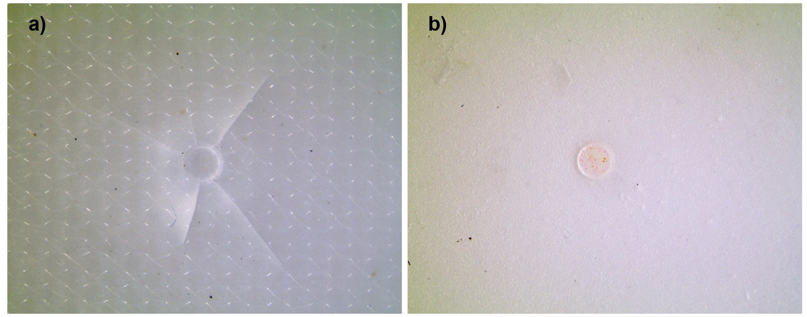
Fig. 1 Statistic distribution of FIMEC curves from (a) Injection moulded samples; (b) Compression moulded samples.
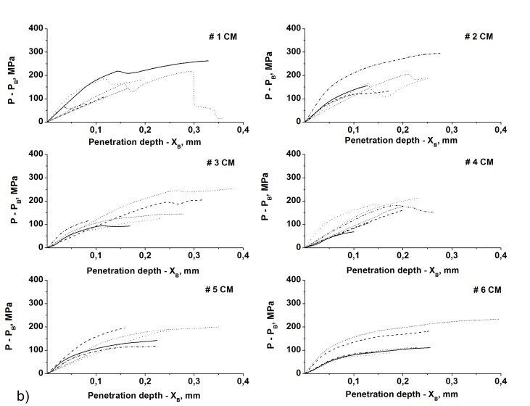
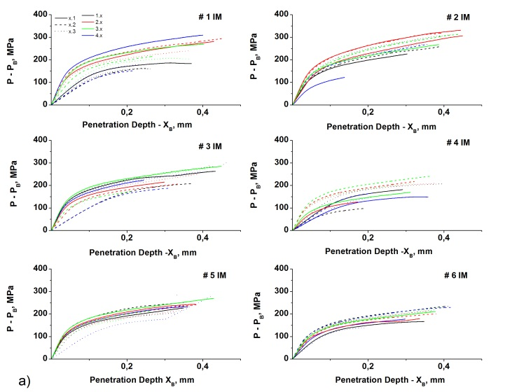
Fig. 2 Visual appearance of (a) compression-moulded sample, and (b) injection-moulded sample after FIMEC testing
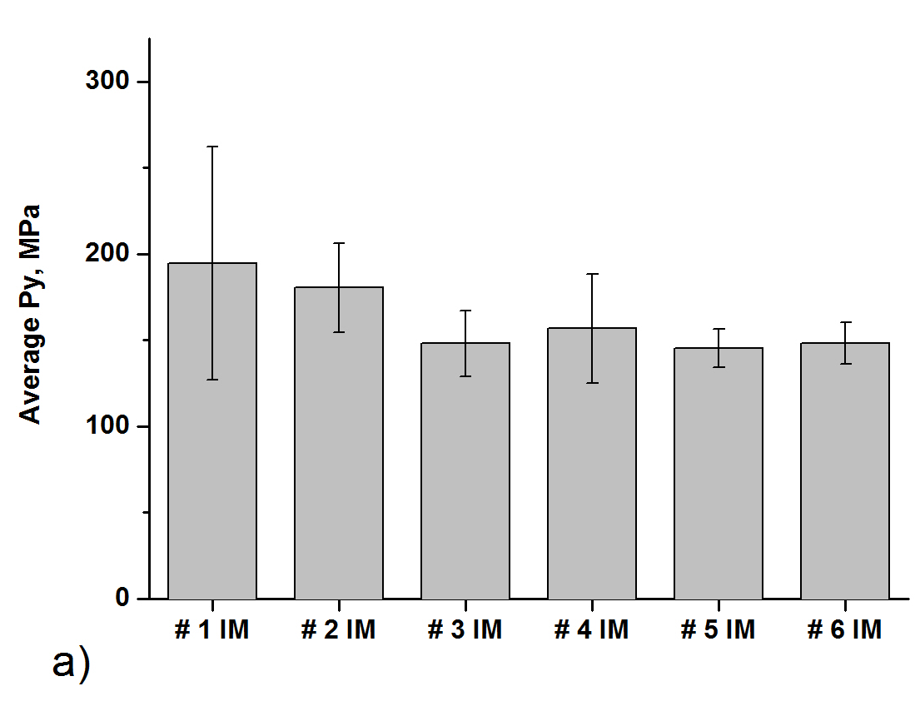
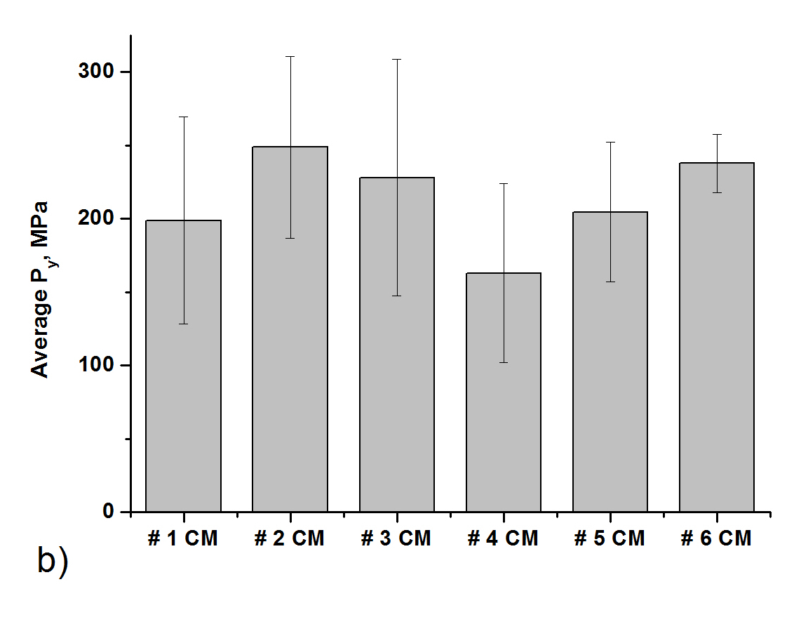
Histograms in Figure 3-a and Figure 4-b provide average pressure P_{y} and average contact stiffness dP/dh values respectively for injection moulding samples, while Figure 3-b and Figure 4-b show the same values obtained for
Fig. 3 Statistic distribution of FIMEC curves from (a) Injection moulded samples; (b) Compression moulded samples
compression moulding samples. All the data with the relative standard deviation are summarized in Table 2 and Table 3.

Table 2. Average values of contact stiffness (dP/dh) and P_{y} obtained by injection molded samples
Sample ID | dP/dh,  MPa/mm | STD  dP/dh,  MPa/mm | P_{y}, MPa | STD  P_{y},  MPa
# 1 IM | 3100 | 500 | 190 | 70
# 2 IM | 2300 | 1000 | 180 | 30
# 3 IM | 3000 | 1000 | 150 | 20
# 4 IM | 2000 | 900 | 160 | 30
# 5 IM | 3000 | 700 | 140 | 10
# 6IM | 2600 | 500 | 150 | 10

Table 3. Average values of contact stiffness (dP/dh) and P_{y} obtained by compression molded samples
Sample ID | dP/dh,  MPa/mm | STD  dP/dh,  MPa/mm | P_{y}, MPa | STD  P_{y,}  MPa
# 1 CM | 1400 | 600 | 200 | 70
# 2 CM | 1600 | 300 | 250 | 60
# 3 CM | 1200 | 200 | 230 | 80
# 4 CM | 1000 | 200 | 160 | 60
# 5 CM | 1500 | 400 | 200 | 50
# 6 CM | 1300 | 500 | 240 | 20

Within injection moulded scenarios, reference samples, prepared by the compounding of PLA and compatibilizing agent only, showed the higher values of average pressure, P_{y}, being these equal to 180 and 190 MPa respectively, against values that ranges from 140 to 160 MPa found with blended samples. This result was expected since the polymers that compose the blend are immiscible. Under such condition, the interface between the dispersed phases and the PLA matrix constitutes a discontinuity in the material, lowering its capability to recover the deformation impressed by the indenter. No significant differences were found among blend formulations in injection moulding samples. Conversely, a visible difference between injection moulded and compression moulded samples was found, since the latters do not feature any systematic differences in the behaviour of reference samples with respect to blend scenarios. This result is strongly indicative of the influence of compression moulding processing on the internal micro-structure of tiles. The increased stiffness and fragility found with CM samples was indeed a more decisive factor on the final behaviour of the sample than its chemical composition. This finding was likely correlated to the crystalline content of the tiles obtained by compression moulding that was found by authors to be higher than for IM samples ²⁴ is previous studies. Moreover, the longer exposition of the engineered polymer at high temperature suitable to the onset of branching reaction of the PLA-MA ²⁵ was also hypothesized as a possible reason for the increase of CM sample stiffness. Indeed, a polymeric material enclosing more rigid small structures, such as crystallites, may request higher pressure to reach the molecularly displacement requested for a permanent plastic deformation. Furthermore, the presence of crystallites can act, as described in literature ²⁶, as cohesive agent increasing the adhesion among immiscible phases. Parallel, the effective occurrence of branching reactivity of PLA-MA is evincible from the considerable increase in P_{y} of reference sample # 2 CM with respect to reference sample # 1 CM, as the consequence of the higher concentration in PLA-MA. The combination of these two possible factors influences the mechanical behaviour of the compression moulded samples in a more determining way than the presence of a discontinue structure given by the extraneous phases as in IM samples, amending the effects of the discontinuities. The influence of compatibilizing agent in the scenario of compression moulded specimens, also clearly emerged from the analysis of blend samples. Figure 3-b reports an increasing trend of the P_{y} values with the increase of the absolute content in compatibilizing agent moving from sample # 4 CM to # 6 CM. The pressure at which the material begins to permanently protrude around the indenter increases with the increase of dispersing agent in the blends. This behaviour is still explainable with the increase of the cross linking degree within the polymeric structure due to the branching effect of PLA-MA. The presence of ties impedes, or reduces, the average distance that two chains, that interacts each other through weak physical bonds, can tread. Smaller movements avoid the breakage of physical bonds avoiding the onset of plastic deformation. Concurrently, in blend samples, the same reactive mechanism induces an increased affinity between dispersed phases amending the loss of strength that would results from the introduction of voids and discontinuities at the interface as evidenced by the comparison of these samples. The confrontation of P_{y} values relative to samples # 3 CM and sample # 5 CM only provided information of minor significance since the increase in dispersing agent concentration did not lead to a considerable P_{y} increase. Actually, the lower concentration of extraneous phases creates discontinuity at the phases interface that is easily amended yet at lower concentration of PLA-MA.
Contact stiffness was then evaluated for both compression moulding and injection moulding samples. Bar plots in Figure 4 report dP/dh values against the adopted formulation.
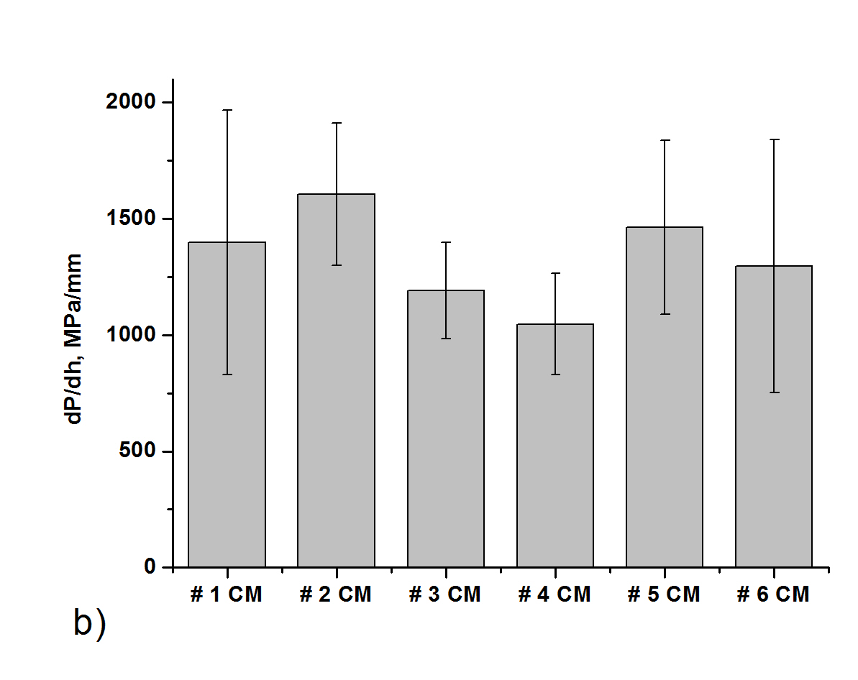
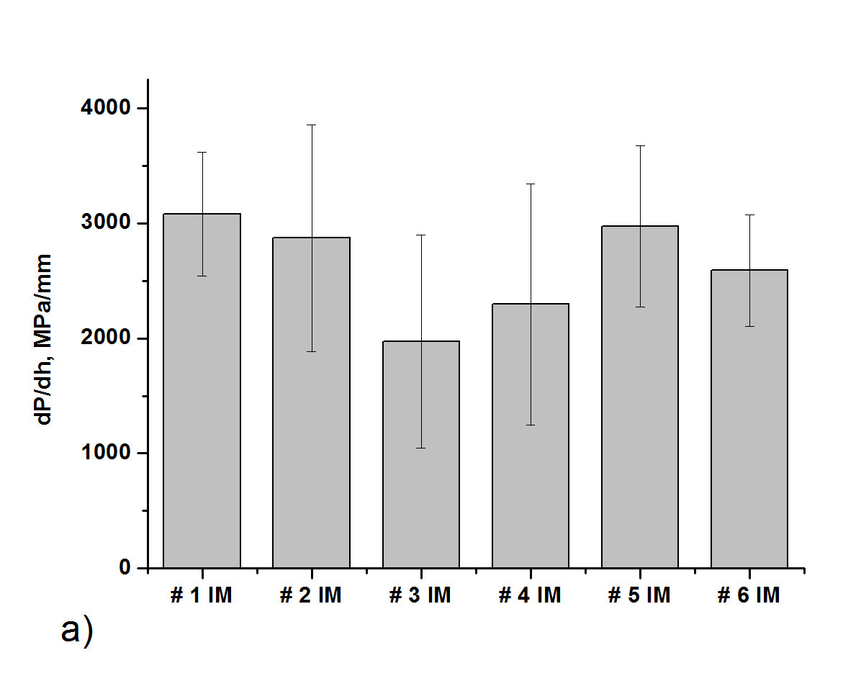
Fig. 4 Histogram of contact stiffness, dP/dh, of (a) Injection moulded samples; (b) Compression moulded samples

As observed in Figure 1-a, where P_{y} values of injection moulding were illustrated, the bar plot in Figure 4-a evidences a substantial difference between the behaviour of reference samples # 1 IM and # 2 IM and the behaviour of samples # 3 IM and # 4 IM. These two latter samples feature a low content in PLA-MA compatibilizing agent, while they feature a content of PBS and PBT of 5 and 10 % w.t. respectively. The values of contact stiffness, also reported in Table 2, evidence the effect of the addition of extraneous phase resulting in a loss in the material rigidity. This can be considered the direct consequence of the addition of softer phases, namely PBS and PBT featuring, respectively, an Elastic modulus of 540 MPa 2600 MPa against the 3500 MPa of PLA ²⁰, as well as the introduction of discontinuities and voids at the interface of immiscible phases. The observation of histograms and dP/dh values relative to samples # 5 IM and # 6 IM seems to corroborate the latter hypothesis. Indeed, the addition of higher concentration, 4 % w.t., of PLA-MA in presence of content of PBS and PBT as in sample # 3 IM and # 4 IM respectively, leads to the restoration of the original stiffness found in the reference samples. An pretty analogous behaviour was registered with compression moulding samples as reported in Figure 4-b despite the differences induced by the longer process reflected in the increase of stiffness of reference sample # 2 CM with respect to reference sample # 1 CM.

4. Conclusions

In the present study, a method for the production of PLA formulations with improved thermal resistance, suitable for interesting application in the food packaging segment, was developed. In particular the engineered PLA was found to be suitable to the injection moulding and compression moulding processes that is the production technique commonly adopted for the manufacturing of coffee capsules. The strategy exploited the high HDT and toughness of PBT, the high ductility of PBS, that were melt blended within a PLA matrix without affecting its compostability. The presence of discontinuities at the interface of phases arisen from the immiscibility of PLA/PBS/PBT was then amended by the addition of PLA-MA, with the aim of making the mechanical properties of the material suitable for industrial applications. The effectiveness of the compatibilizing agent was found to be significantly higher when processing techniques having longer heating and cooling times was adopted that allows the PLA-MA to fully react. The efficiency of this strategy was also related to the concentration of PLA-MA that must be accurately proportioned to the content of extraneous phases. The selected dispersing agent resulted effective due to its ability to react with -OH terminal groups of PBT and PBS, and, on the other side, its affinity with the PLA matrix. It was found that the addition of PLA-MA alone still exert a reinforcing action on the neat PLA, through a branching reaction.

5. References

1. Chang J-H, Uk-An Y, Sur GS (2003) Poly (lactic acid) nanocomposites with various organoclays. I. Thermomechanical properties, morphology, and gas permeability. J Poly Sci B: Poly Phys 41:94–103
2. Murariu M, Dubois P, PLA composites: From production to properties, Adv. Drug. Deliv. Rev. 2016;107:17-46
3. Ouchiar S, Stoclet G, Cabaret C, Georges E, Smith A, Martias C, Addad A, Gloaguen V, Comparison of the influence of talc and kaolinite as inorganic fillers on morphology, structure and thermomechanical properties of polylactide based composites. Appl. Clay Sci. 2015;116–117: 231-240
4. Yang Y, Zhang L, Xiong Z, Tang Z, Zhang R, Zhu J, Research progress in the heat resistance, toughening and filling modification of PLA. Sci. China Chem. 2016;59:1355-1368
5. Suprakas S.R., K. Yamada, M. Okamoto, K. Ued. New polylactide-layered silicate nanocomposites. 2. concurrent improvements of material properties, biodegradability and melt rheology. Polymer 2003;44: 857-866
6. Suprakas S R, Bousmina M. Biodegradable polymers and their layered silicate nanocomposites: In greening the 21st century materials world''. Prog. Mater. Sci. 2005;50: 962-1079
7. Lee B-H, Kim H-S, Lee S, Kim H-J, Dorgan J R, Bio-composites of kenaf fibers in polylactide: Role of improved interfacial adhesion in the carding process. Compos. Sci. Technol. 2009;69:2573–2579
8. Shakoor A, Thomas N L, Talc as a nucleating agent and reinforcing filler in poly(lactic acid) composites. Polym. Eng. Sci. 2014;54:64–70
9. Gao Y, Picot O T, Bilotti E, Peijs T, Influence of filler size on the properties of poly(lactic acid) (PLA)/graphene nanoplatelet (GNP) nanocomposites. Eur. Polym. J. 2017;86:117–131
10. Issaadi K, Habi A, Grohens Y, Pilli I, Effect of the montmorillonite intercalant and anhydride maleic grafting on polylactic acid structure and properties. Appl. Clay Sci. 2015;107:62–69
11. Yang W, Fortunati E, Dominici F, Kenny J M, Puglia D, Effect of processing conditions and lignin content on thermal,mechanical and degradative behavior of lignin nanoparticles/polylactic (acid) bionanocomposites prepared by melt extrusion and solvent casting. Eur. Polym. J. 2015;71:126–139
12. Wang Y, Chiao S M, Hung T-F, Yang S-Y, Improvement in Toughness and Heat Resistance of Poly(lactic acid)/Polycarbonate Blend Through Twin-Screw Blending: Influence of Compatibilizer Type. J. Appl. Polym. Sci. 2012;125: 402–412
13. Guo X, Zhang J, Huang J, Poly(lactic acid)/polyoxymethylene blends: Morphology, crystallization, rheology, and thermal mechanical properties. Polymer 2015;69:103-109
14. Hashima K, Nishitsuji S, Inoue T, Structure-properties of super-tough PLA alloy with excellent heat resistance. Polymer 2010;51:3934-3939
15. Balaguer M.P., Aliaga C., Fito C., Hortal M., Compostability assessment of nano-reinforced poly(lactic acid) films, Waste Management 2016; 48: 143-155
16. Pradhan R., Misra M., Erickson L., Mohanty A., Compostability and biodegradation study of PLA–wheat straw and PLA–soy straw based green composites in simulated composting bioreactor, Bioresource Technology 2010; 101: 8489-8491
17. Singh G, Kaur N, Bhunia H, Bajpai PK, Mandal UK. Degradation behaviors of linear low-density polyethylene and poly(L-lactic acid) blends. Journal of Applied Polymer Science 2011;124: 1993-199818. Ouhib, R.; Renault, B., Mouaziz, H.; Nouvel, C.; Dellacherie, E.; Six, J.L. Biodegradable amylose-g-PLA glycopolymers from renewable resources. Carbohydrate Polymers 2009; 77: 32-40
19. Gisario A., Veniali F., Barletta M., Tagliaferri V., Vesco S., Laser transmission welding of poly(ethylene terephthalate) and biodegradable poly(ethylene terephthalate) – Based blends, Optics and Lasers in Engineering, 2017; 90: 110-118
20. Di Lorenzo M. L., Rubino P., Cocca M., Miscibility and properties of poly(l-lactic acid)/poly(butylene terephthalate) blends. European Polymer Journal 2013; 49: 3309-3317
21. Chen G-X, Kim H –S, Yoon J –S, Compatibilization-like effect of reactive organoclay on the poly(L-lactide)/poly(butylene succinate) blends. Polymer 2005;46: 11829–11836
22. Wu C –S, Renewable resource-based composites of recycled natural fibers and maleated polylactide bioplastic: Characterization and biodegradability. Polymer Degradation and Stability 2009; 94: 1076–108423. Castro-Aguirre E., Iñiguez-Franco F., Samsudinb H., Fang X., Auras R., Poly(lactic acid)—Mass production, processing, industrial applications, and end of life, Advanced Drug Delivery Reviews 2016; 107: 333–366
24. Barletta M., Moretti P., Pizzi E., Puopolo M., Tagliaferri V., Vesco S., Engineering of Poly Lactic Acids (PLAs) for melt processing: Material structure and thermal properties Authors; Journal of applied polymer science, 2017; 134, 44504
25. Zhong W, Ge J, Gu Z, Li W, Chen X, Zang Y, Yang Y, Study on Biodegradable Polymer Materials Based on Poly-(lactic acid). I. Chain Extending of Low Molecular Weight Poly(lactic acid) with Methylenediphenyl Diisocyanate, Journal ofApplyed Polymer Science 1999;74: 2546-2551
26. Wook Kim M, Seok Song Y, Ryoun Youn J, Effects of interfacial adhesion and crystallization on the thermos-resistance of poly(lactic acid)/mica composites. Composites: Part A 2010; 41: 1817-1822

